HANOI UNIVERSITY OF SCIENCE AND TECHNOLOGY
School of Information and communications technology

Software Design Document
Version 1.3

An Internet Media Store
Subject: ITSS Software Development
Group 6
Vũ Hải Đăng-20225962
Nguyễn Minh Khôi-20226050
Lê Đại Lâm-20225982
Phạm Thành Nam-20225989
Bùi Xuân Sơn-20226065

Hanoi, 05, 2025
<All notations inside the angle bracket are not part of this document, for its purpose is for extra instruction. When using this document, please erase all these notations and/or replace them with corresponding content as instructed>
<This document, written by Prof. NGUYEN Thi Thu Trang, is used as a case study for student with related courses. Any modifications and/or utilization without the consent of the author is strictly forbidden>

Table of Contents

Table of Contents 1
1 Introduction 5
1.1 Objective 5
1.2 Scope 5
1.3 Glossary 5
1.4 References 5
2 Overall Description 7
2.1 General Overview 7
2.2 Assumptions/Constraints/Risks 7
2.2.1 Assumptions 7
2.2.2 Constraints 7
2.2.3 Risks 8
3 System Architecture and Architecture Design 9
3.1 Architectural Patterns 9
3.2 Interaction Diagrams 9
3.3 Analysis Class Diagrams 9
3.4 Unified Analysis Class Diagram 9
3.5 Security Software Architecture 9
4 Detailed Design 10
4.1 User Interface Design 10
4.1.1 Screen Configuration Standardization 10
4.1.2 Screen Transition Diagrams 10
4.1.3 Screen Specifications 10
4.2 Data Modeling 10
4.2.1 Conceptual Data Modeling 10
4.2.2 Database Design 10
4.3 Non-Database Management System Files 11
4.4 Class Design 11
4.4.1 General Class Diagram 11
4.4.2 Class Diagrams 11
4.4.3 Class Design 11
5 Design Considerations 13
5.1 Goals and Guidelines 13
5.2 Architectural Strategies 13
5.3 Coupling and Cohesion 14
5.4 Design Principles 14
5.5 Design Patterns 15

List of Figures
No table of figures entries found.

List of Tables
Table 1. Example of table design 10
Table 1. Example of attribute design 12
Table 1. Example of operation design 12
Table 4. Example of attribute design 14

Introduction
The following subsections of the Software Design Document (SDD) provide an overview of the architectural and design specifications for AIMS: An Internet Media Store. This document translates the functional requirements defined in the Software Requirements Specification (SRS) into technical design components and implementation guidelines.

Objective
The objective of this Software Design Document is to provide detailed architectural and design specifications for the AIMS: An Internet Media Store system. This document serves as a technical blueprint that outlines the system's structural organization, component interactions, data models, and implementation strategies.
The intended audience includes:
- Software Architects: To validate the overall system architecture and design patterns
- Software Engineers/Developers: To implement the system components according to specified designs
- Database Administrators: To design and implement the data storage solutions
- Technical Project Managers: To oversee technical development progress and resource allocation
- Quality Assurance Engineers: To develop test strategies based on the architectural design
- System Integrators: To understand component interfaces and integration points
- Technical Writers: To create implementation documentation and API specifications
This document bridges the gap between requirements (defined in the SRS) and implementation, ensuring all technical stakeholders have a clear understanding of how the system will be constructed.

Scope
The AIMS: An Internet Media Store is a desktop-based e-commerce application designed for the management and sale of physical media products. This design document covers the complete technical architecture for:
- Product Management Subsystem
- Product catalog management with support for Books, CDs, LP records, and DVDs
- Inventory management with real-time stock tracking
- Price management with business rule enforcement
- Product attribute management based on media type
- User Management Subsystem
- Role-based access control for Administrators, Product Managers, and Customers
- User authentication using token-based security
- User account lifecycle management
- E-commerce Transaction Subsystem
- Shopping cart management with session persistence
- Order processing workflow including standard and rush delivery options
- Payment integration with VNPay payment gateway
- Order status tracking and management
- Integration Subsystem
- VNPay API integration for payment processing
- Email notification system for order confirmations and user management
- External shipping calculation services
- Technical Scope:
- Multi-user desktop application supporting up to 1,000 concurrent users
- Response time requirements: ≤2 seconds normal operation, ≤5 seconds peak hours
- Uptime requirement: 300 hours continuous operation
- Recovery time: ≤1 hour maximum downtime after failure
- Out of Scope:
- Digital media product sales
- Alternative payment methods beyond credit cards
- Mobile application versions
- Real-time chat support
- Customer account creation (customers can purchase without accounts)
The system architecture will be designed for scalability, maintainability, and performance, with clear separation of concerns between business logic, data access, and presentation layers.

Glossary
No | Term | Explanation | Example | Note
1 | MVC (Model-View-Controller) | Architectural pattern separating application logic into three interconnected components | User interface (View), Business logic (Controller), Data handling (Model) | Used for organizing code structure
2 | API (Application Programming Interface) | Set of protocols and tools for building software applications | VNPay Payment API | Enables system integration
3 | Session Management | Process of maintaining user state and cart data during software interaction | Shopping cart persistence during user session | Critical for e-commerce functionality
4 | Database Transaction | Sequence of database operations performed as a single logical unit | Order placement with inventory update | Ensures data consistency
5 | Repository Pattern | Design pattern that separates data access logic from business logic | ProductRepository, OrderRepository | Abstracts database operations
6 | Factory Pattern | Design pattern for creating objects without specifying the exact class | MediaProductFactory for Books, CDs, DVDs | Creates objects based on media type
7 | Observer Pattern | Design pattern where objects notify other objects about state changes | Inventory update notifications | Used for real-time updates
8 | DTO (Data Transfer Object) | Object that carries data between processes | PaymentDTO, OrderDTO | Reduces method calls
9 | Singleton Pattern | Design pattern ensuring a class has only one instance | DatabaseConnection, EmailService | Manages shared resources
10 | Service Layer | Architectural layer containing business logic | OrderService, PaymentService | Separates business logic from data access
11 | ORM (Object-Relational Mapping) | Technique for converting incompatible type systems | Entity classes mapped to database tables | Simplifies database operations
12 | Dependency Injection | Design pattern for achieving Inversion of Control | Injecting PaymentService into OrderController | Improves testability and flexibility
13 | RESTful Architecture | Architectural style for designing networked applications | HTTP methods for CRUD operations | Used for external API integration
14 | Load Balancer | System that distributes network traffic across multiple servers | Round-robin request distribution | Supports 1,000 concurrent users
15 | Cache | Temporary storage for frequently accessed data | Product catalog cache | Improves response time

References
Centers for Medicare & Medicaid Services. (n.d.). System Design Document Template. Retrieved from Centers for Medicare & Medicaid Services: https://www.cms.gov/Research-Statistics-Data-and-Systems/CMS-Information-Technology/XLC/Downloads/SystemDesignDocument.docx

Overall Description

General Overview
The system in question is an online media store designed to enable customers to purchase digital media products conveniently. This software functions as a comprehensive platform, catering not only to customers but also to product managers.
The system consists of three primary actors:
- Customer: Customers can look at, search for, and sort products in the store. To buy something, they must add or update items in their cart and provide delivery details. Once all information is correctly entered, they can proceed with payment via VNPay. Upon a successful transaction, AIMS will send an email confirmation along with the invoice. In certain cases, customers also have the option to place rush orders..
- Product Manager: Using the management interface provided by AIMS, product managers can efficiently oversee their store’s inventory. They have full control over adding, removing, and updating product details. Additionally, they can manage pending orders by either approving or rejecting them.
- Administrator: Administrators hold the authority to manage users within the system. They can create new user accounts, update user information, and block or unblock users as needed.
A Use Case diagram shows how actors interact with different use cases in the system. It represents the system's functional requirements by illustrating the interactions between external and internal agents.
The diagram below presents the general use case diagram of AIMS software, highlighting the actors and their associated use cases.

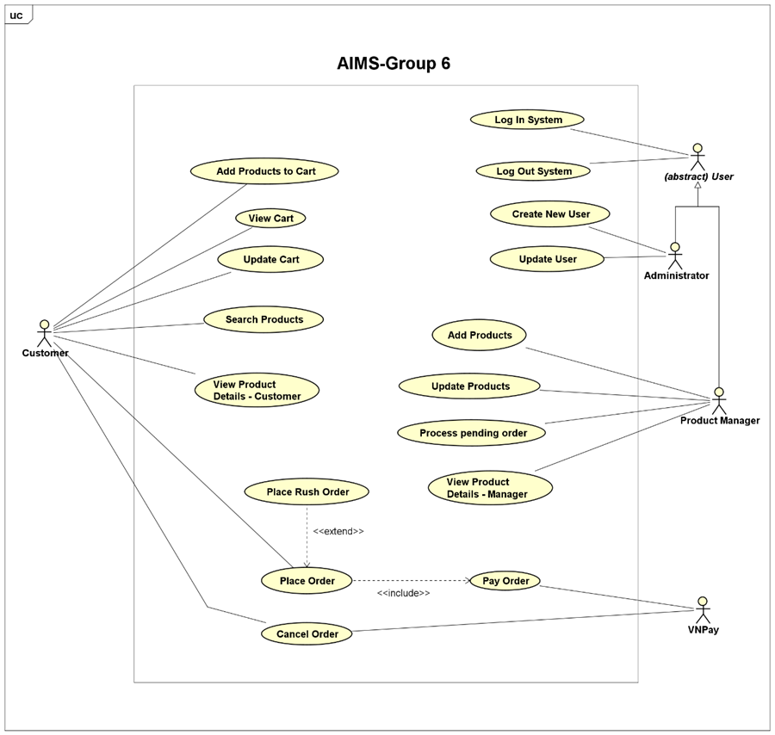 In the AIMS software, five core business operations are defined: "Place Order," "Place Rush Order," "Pay Order," "Cancel Order," and "Process Pending Order." Each of these operations is thoroughly illustrated using an activity diagram in its respective section. Below, we present the activity diagrams for all use cases in the AIMS software.
Activity diagrams are utilized to model business processes as they provide a structured visual representation of workflows, decision points, and resource allocation. These diagrams enable stakeholders to understand, analyze, and refine complex processes by depicting the sequence of activities, concurrency, error handling, and integration with other models. Additionally, they function as effective documentation tools, enhancing communication and collaboration among stakeholders.

2.1.1 Business operation- Pay Order
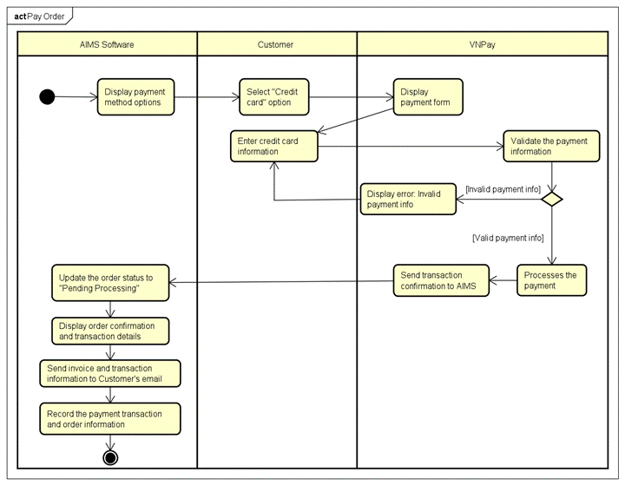2.1.2 Business operation- View Product Detail
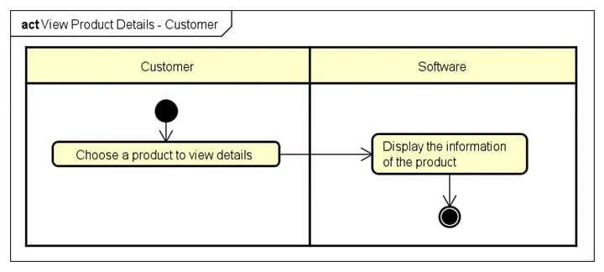

2.1.3 Business operation- Add Product
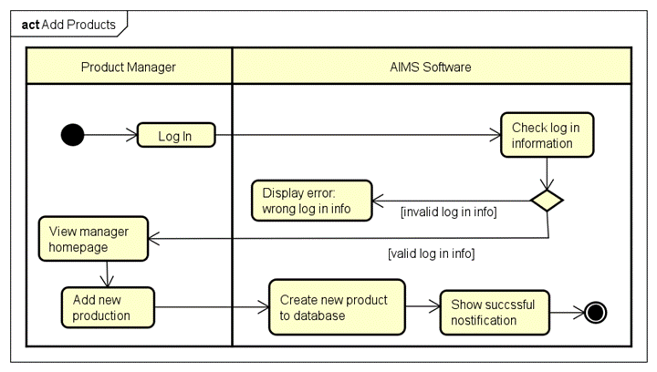
2.1.4 Business operation- Update Product
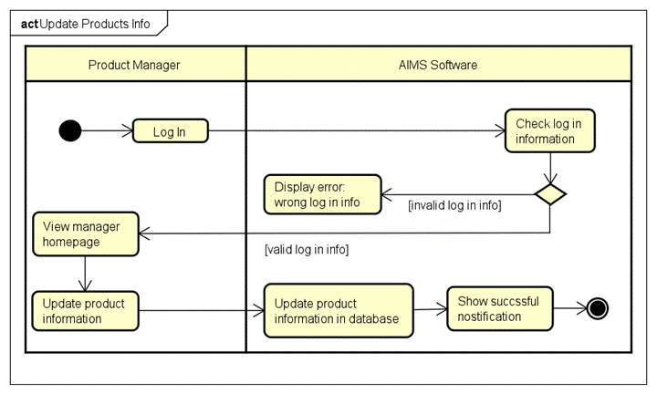

2.1.5 Business operation- Place Order
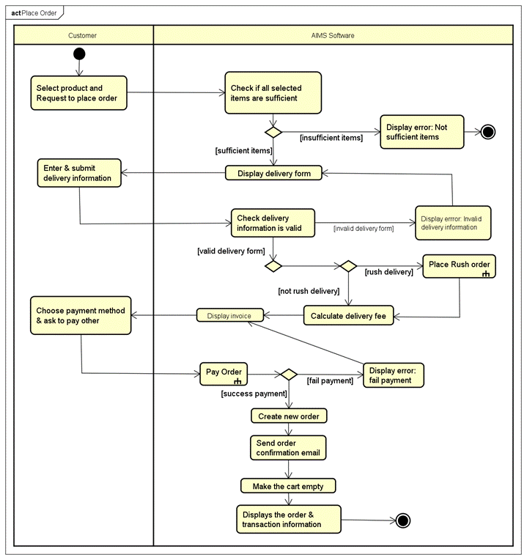

2.1.6 Business operation- Place Rush Order
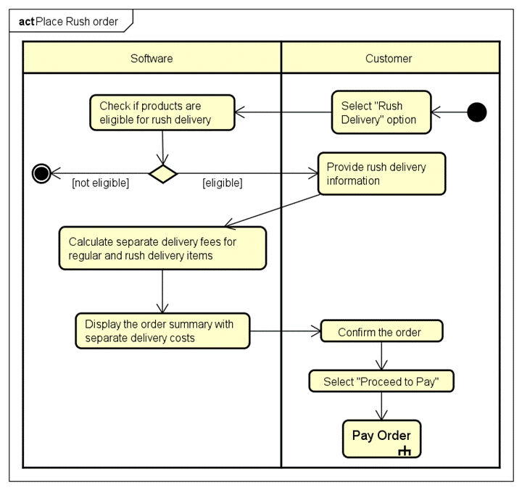

2.1.7 Business operation- Cancel Order
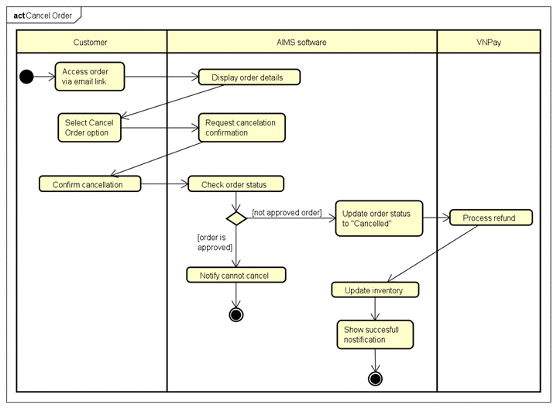

2.1.8 Business operation- Add product to Cart

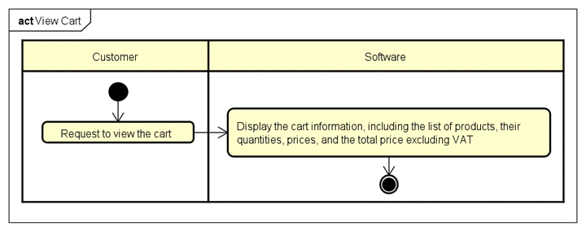

2.1.9 Business operation- View Cart
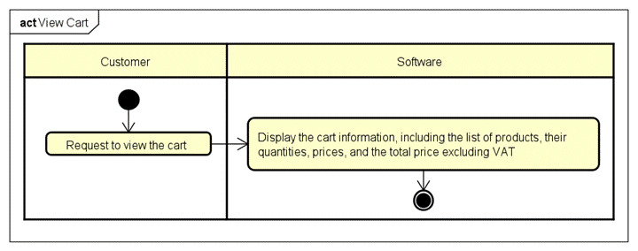2.1.10 Business operation- Update Cart
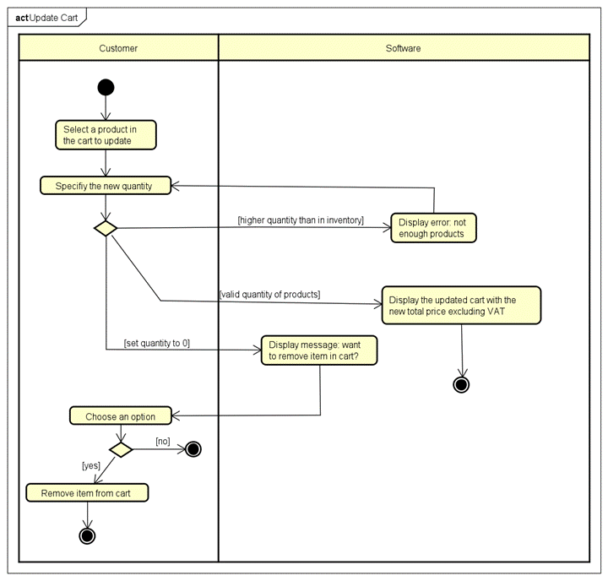

2.1.11 Business operation- Process Pending Order
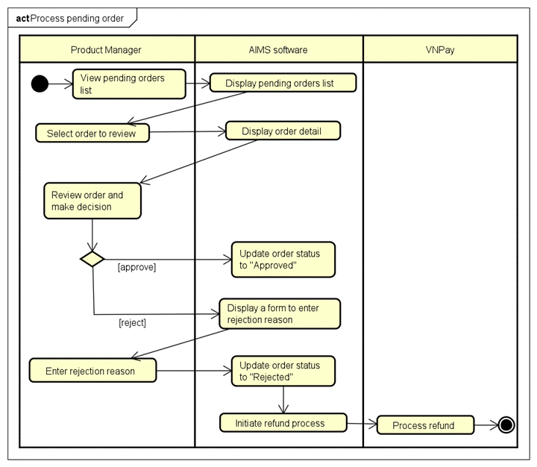

2.1.12 Business operation- Search Product
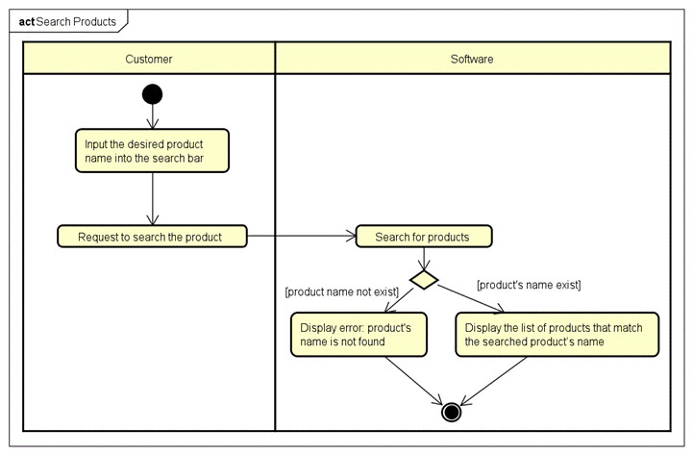

2.1.13 Business operation- Create User
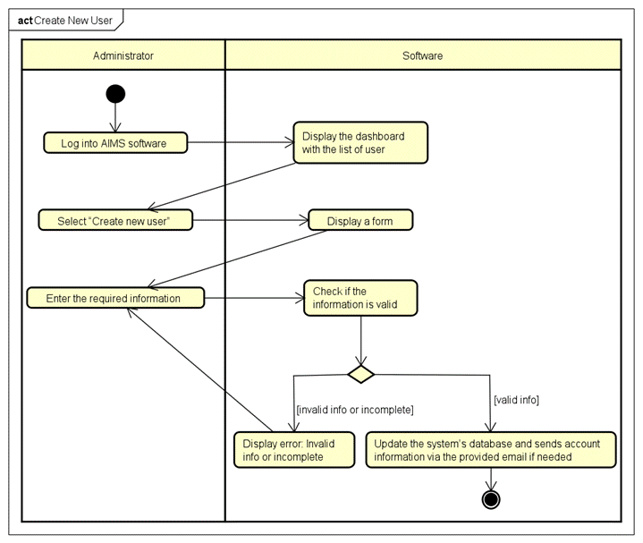

2.1.14 Business operation- Update User
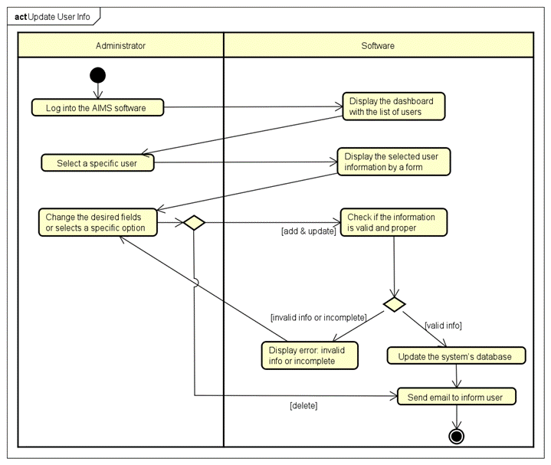

Assumptions/Constraints/Risks

Assumptions
- Software and Hardware Dependencies: The AIMS platform is intended to function efficiently within a standard Java application environment. A conventional relational database management system (such as SQLite) will be employed for data storage and management.
- Operating System Compatibility: The system will be primarily developed and deployed in a Windows environment; however, the final application must ensure cross-platform compatibility, particularly with both Windows and macOS operating systems.
- User Profile Assumptions: It is assumed that target users possess a basic level of digital literacy, including familiarity with navigating online marketplaces and interacting with digital media platforms.Users are expected to have reliable internet connectivity and access to devices capable of streaming or downloading media content.
- Functional Evolution :Anticipated future enhancements may involve the addition of new media formats or the integration of alternative payment systems. Accordingly, the system must be designed with a modular and adaptable architecture. The platform architecture should facilitate scalability, allowing for the integration of new features with minimal structural modifications.

Constraints
The design and implementation of the system are subject to a range of global constraints that significantly influence decisions regarding hardware architecture, software development, communication protocols, and overall system functionality. These constraints, derived from technical, operational, legal, and environmental factors, are outlined below along with their associated impacts:
- Hardware and Software Environment Constraints: The system must be compatible with standard Java-based applications and operate efficiently within commonly used desktop environments (e.g., Windows and macOS). This constraint necessitates cross-platform compatibility in both the user interface and backend components, thereby influencing the choice of development frameworks and runtime environments.
- End-User Environment Constraints: The target user base is expected to possess only a basic level of digital proficiency and operate within diverse computing environments. This necessitates a user-friendly interface and robust error handling to accommodate varying levels of technical expertise and device capabilities.
- Availability and Volatility of Resources: Fluctuations in human resources and funding availability may affect development timelines and operational continuity. Moreover, reliance on third-party APIs for critical functions such as payment processing and media delivery requires the system to incorporate fallback mechanisms and modular integration to ensure resilience.
- Standards Compliance and Licensing: The system must adhere to relevant open-source software licenses and digital media distribution agreements. These legal constraints influence the selection of third-party libraries, content handling procedures, and deployment strategies to avoid intellectual property violations.
- Interoperability and Interface Requirements: Integration with third-party services, such as payment gateways (e.g., VNPay) and external media content providers, demands conformance to specified communication protocols and data formats. This imposes architectural constraints on API design, error management, and data exchange mechanisms.
- Data Repository and Distribution Requirements: A centralized SQLite database is employed to manage user accounts, transaction histories, and media inventory. Given the localized nature of SQLite, the system must implement optimized query execution, efficient indexing, and data access patterns to ensure performance, particularly during concurrent operations. While content distribution is not cloud-based, media must be managed efficiently for local playback or controlled download.
- Security and Regulatory Compliance:The system must safeguard user data and financial transactions in compliance with standard security protocols (e.g., HTTPS, encryption, secure authentication). This impacts system architecture by requiring the integration of secure communication channels and robust access control mechanisms.
- Capacity Limitations: As a desktop-based solution, the application must be optimized for limited system memory and processing power. Efficient memory management, resource allocation, and JavaFX performance tuning are essential to support concurrent user actions, background processes, and media operations without degrading user experience.
- Performance Requirements: Users expect quick application startup, smooth navigation, and uninterrupted media playback. To meet these expectations, the system must employ caching strategies, preloading techniques, and efficient media handling logic to minimize latency and ensure responsiveness under varying system loads.
- Network Communication Constraints: The application depends on a stable internet connection for payment processing and media-related operations. However, it must also tolerate network variability through retry logic, connection timeout handling, and asynchronous processing to ensure graceful degradation and uninterrupted user interaction.
- Verification and Validation Requirements:The system must undergo rigorous validation through automated unit tests, integration tests, and user acceptance testing. This is critical to ensure that all components—from the JavaFX front end to the SQLite database and VNPay API integration—function correctly and securely under expected operational conditions.
- Quality Assurance Measures: To ensure long-term reliability and maintainability, the system should adopt continuous integration and delivery (CI/CD) practices, regular code reviews, and scheduled maintenance cycles. Performance monitoring and user feedback mechanisms will also be incorporated to guide iterative improvements and adaptation over time.

Risks
- Third-Party Dependency Risks:
- Identified Risk: The system relies on third-party services for critical functions such as payment processing and media content delivery, which introduces potential points of failure or service disruption.
- Mitigation Strategy: To reduce dependency-related vulnerabilities, the system rchitecture will support integration with multiple service providers. In addition, contingency protocols will be developed to ensure business continuity in the event of third-party service failures.
- Human Resource Risks:
- Identified Risk: A shortage of qualified developers or the loss of key technical personnel may adversely affect project timelines and product quality.
- Mitigation Strategy: This risk will be addressed through competitive recruitment processes, investment in ongoing staff development, and initiatives focused on employee retention and knowledge transfer.
- Technical and Scalability Risks:
- Identified Risk: As the user base expands, the system may encounter performance degradation or infrastructure limitations.
- Mitigation Strategy: The platform will be designed using scalable cloud-based infrastructure, incorporating techniques such as horizontal scaling and load balancing to accommodate increased demand while maintaining performance standards.

System Architecture and Architecture Design
In this section, we propose the general overview of System Architecture Design. This starts from defining the Architectural Patterns, then we design the interaction diagram using sequence diagrams for the proposed architectural patterns. From the interaction diagrams, we can have the analysis class diagrams, which is the fundamental steps for the detailed-level class diagrams for implementation.

Architectural Patterns
The Entity-Control-Boundary (ECB) architecture design pattern is a software design approach that helps in organizing and structuring code to enhance maintainability, scalability, and clarity. This pattern divides the system into three primary types of components: entities, controls, and boundaries.
Entities represent the core business logic and data of the application. These components encapsulate the main data structures and the operations directly related to the core functionality of the system. Entities are typically designed to be reusable and independent of the specific use cases. They model real-world objects and are responsible for managing and maintaining their state and behavior. For example, in a banking application, entities might include classes such as Account, Customer, and Transaction.
Controls are responsible for coordinating the flow of information between entities and boundaries. They manage the application's use cases, orchestrating the interactions between entities and ensuring the correct sequence of operations. Controls contain the logic that drives the application's processes, ensuring that user inputs are properly processed and that the necessary business rules are applied. For instance, a PlaceOrder control might handle the logic for executing a financial transaction, validating inputs, and updating account balances accordingly.
Boundaries define the interfaces through which the system interacts with external actors, such as users, other systems, or external services. They serve as the point of communication between the application and its environment, encapsulating the specifics of input and output mechanisms. Boundaries translate user actions into requests that the control components can handle and present the results back to the user. Examples of boundaries include user interface components like forms and buttons, web service interfaces, or API endpoints, which serve as subsystems in interface design.
We select this architecture pattern because many advantages it delivers:
- Separation of Concerns: By clearly dividing the system into entities, controls, and boundaries, the ECB pattern ensures a clean separation of concerns, making the codebase more modular and easier to understand.
- Maintainability: Changes in one part of the system (e.g., user interface changes) do not directly impact the core business logic encapsulated in entities, thereby reducing the risk of introducing bugs when making modifications.
- Scalability: The modular nature of the ECB pattern facilitates scalability. New features can be added by creating new controls and boundaries without altering existing entities.
- Testability: The clear separation between entities, controls, and boundaries enhances testability. Business logic can be tested independently of the user interface, and mock boundaries can be used to simulate interactions during testing.

Interaction Diagrams
- Add Product to Cart
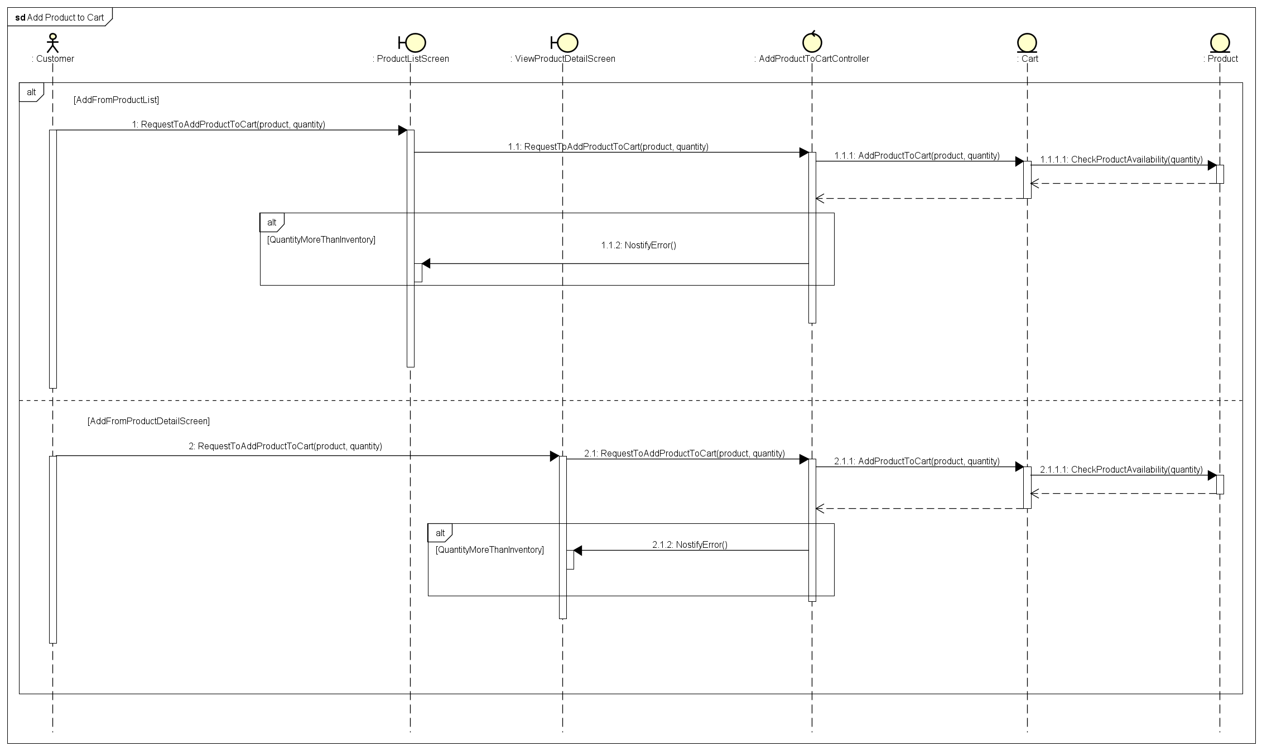
- Add Products
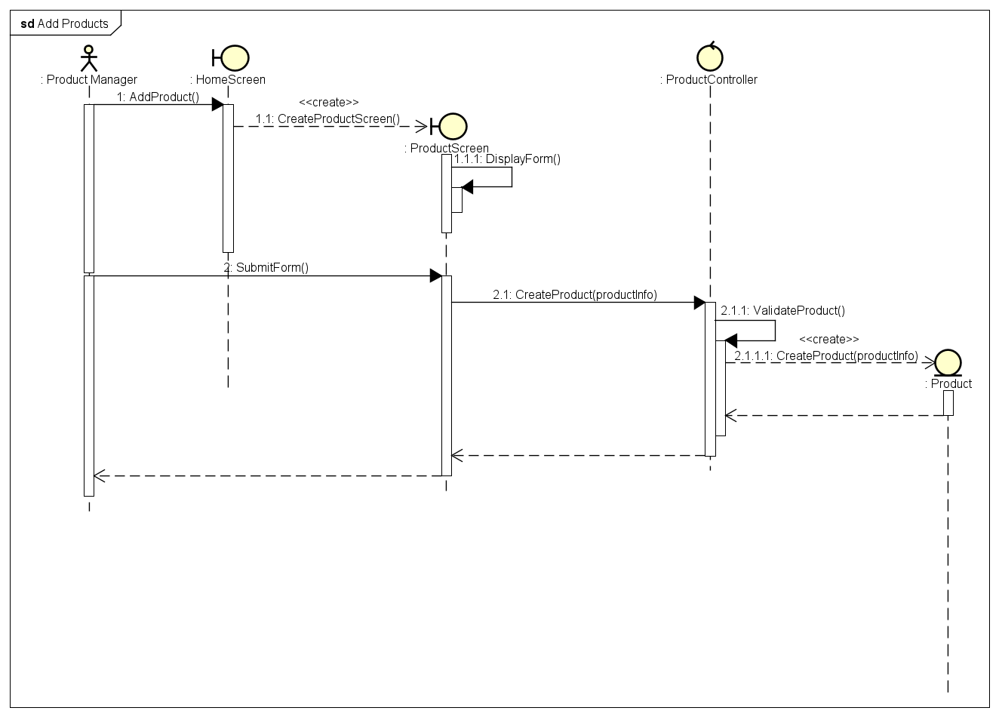
- Cancel Order
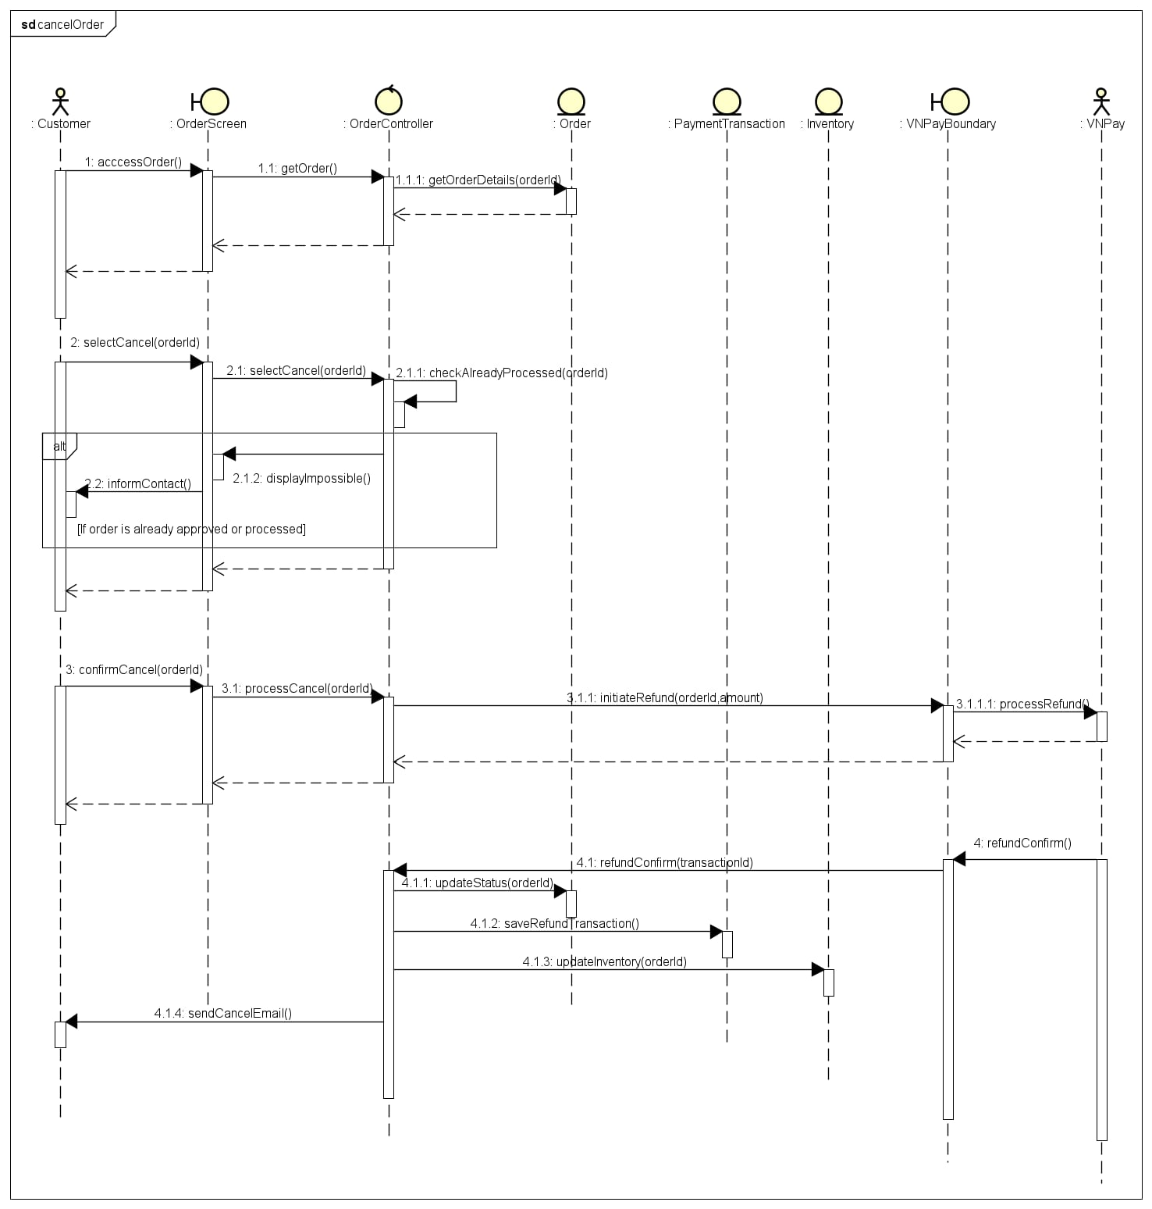
- Create New User
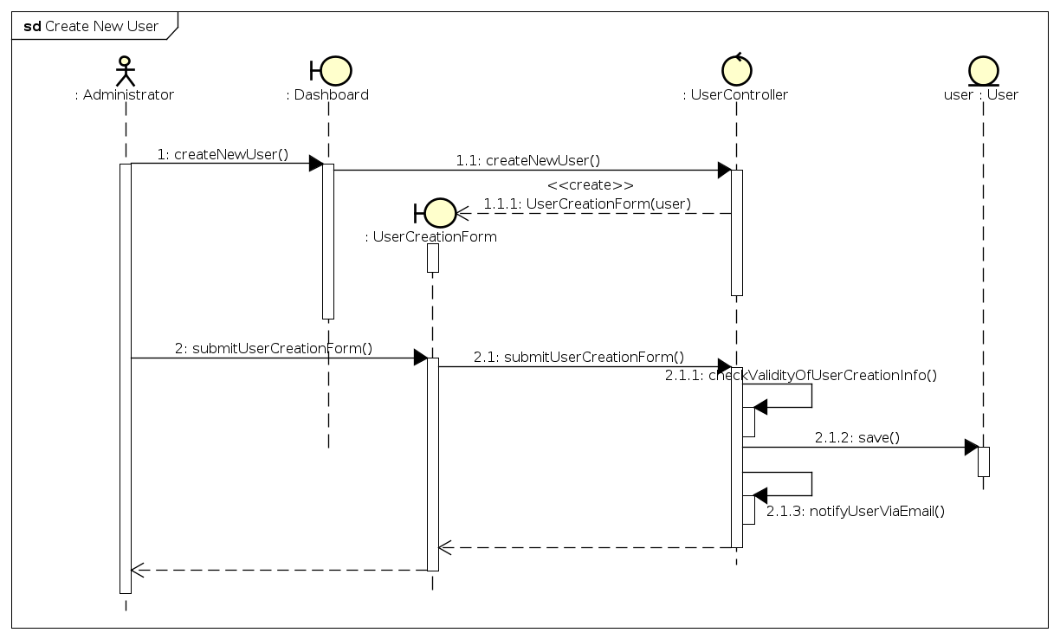
- Pay Order
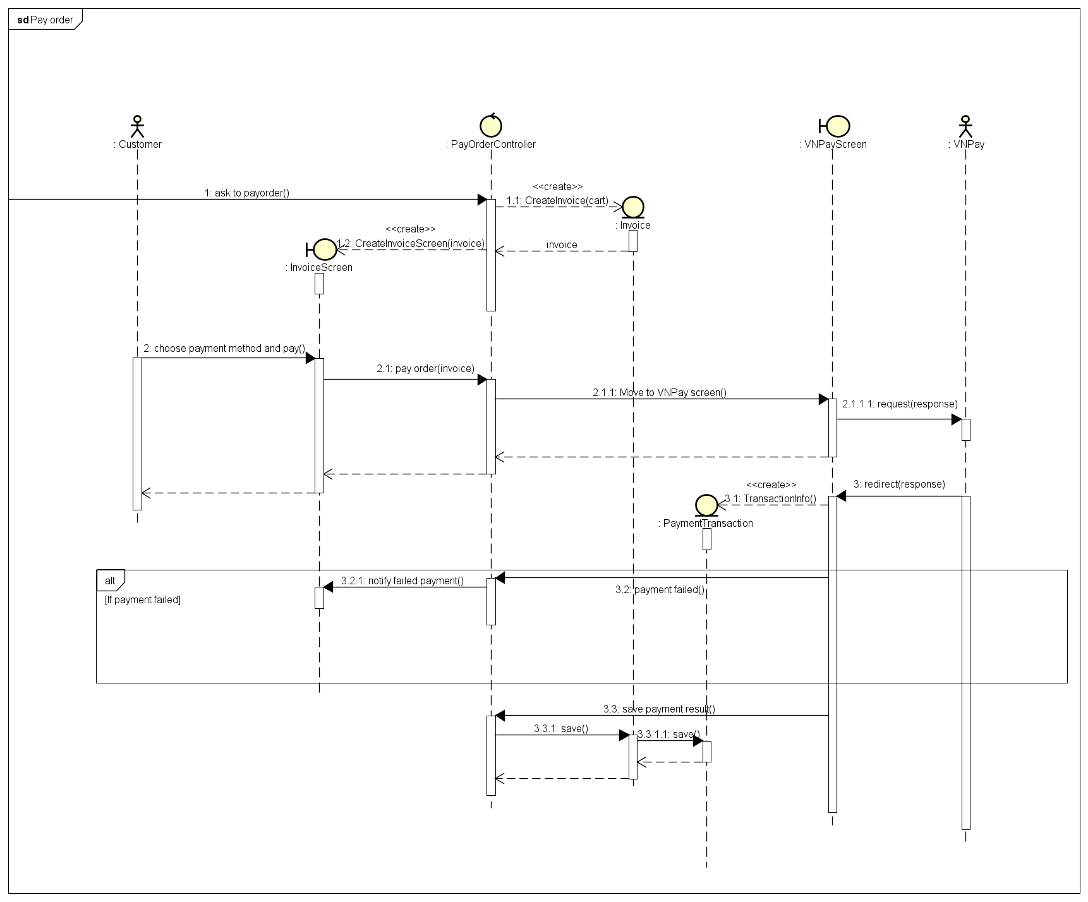
- Place Order
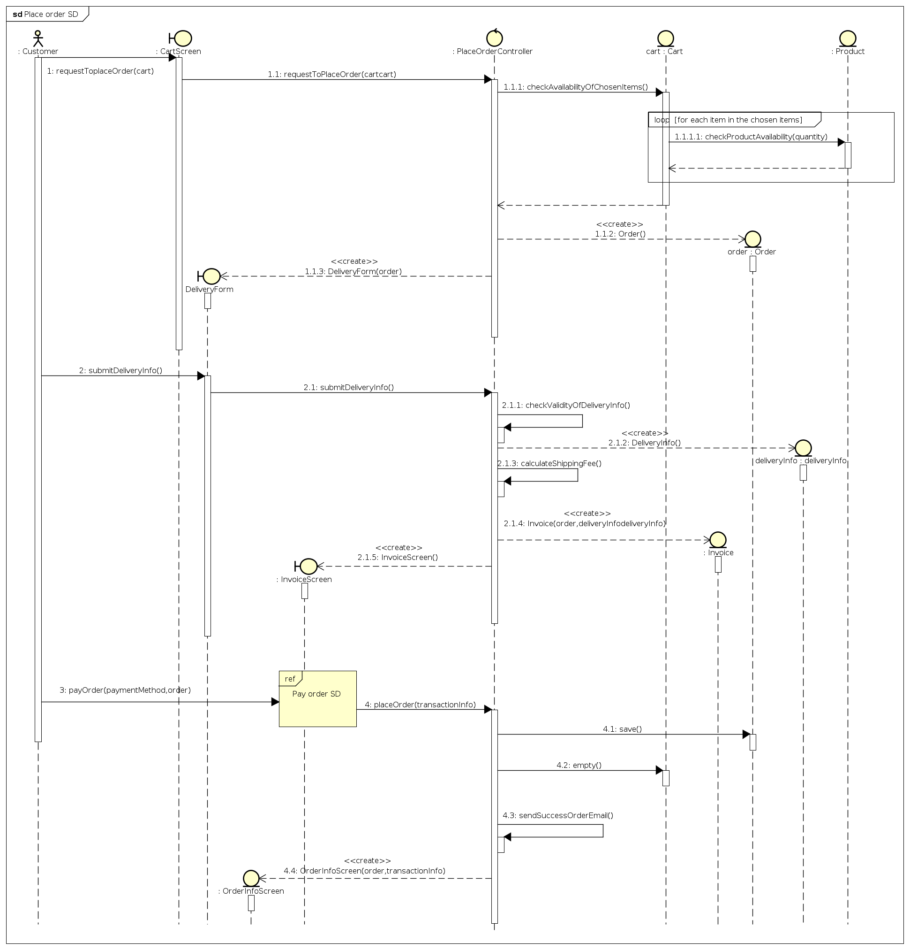
- Place Rush Order
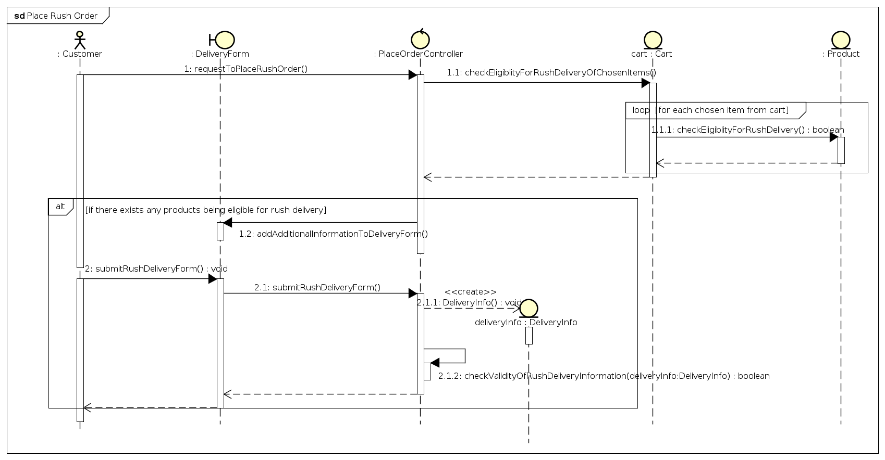
- Process pending order
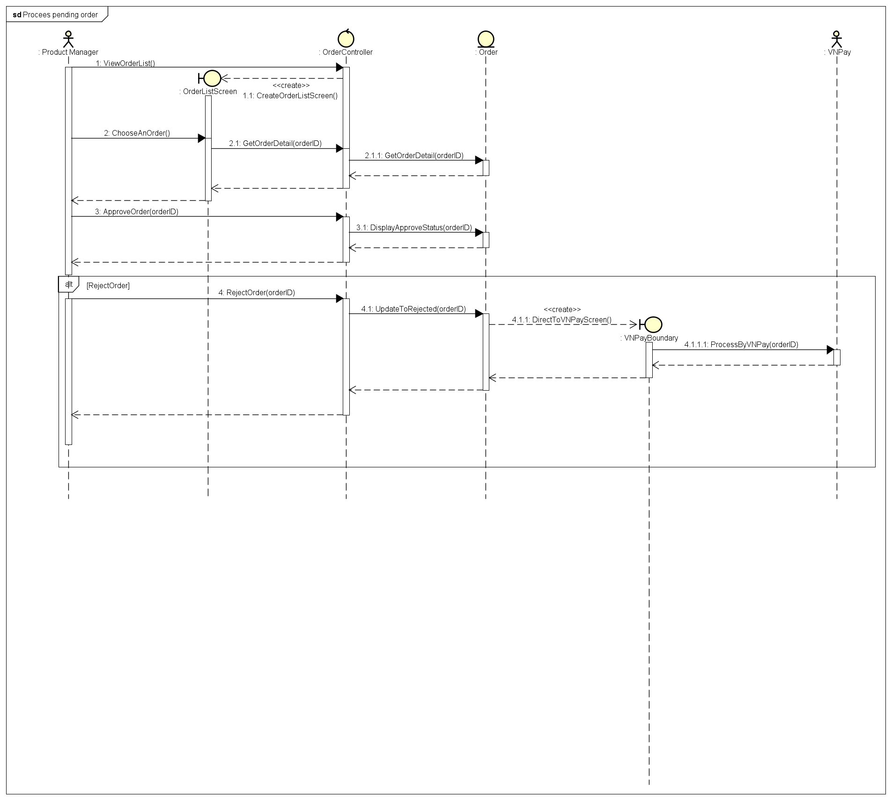
- Search product
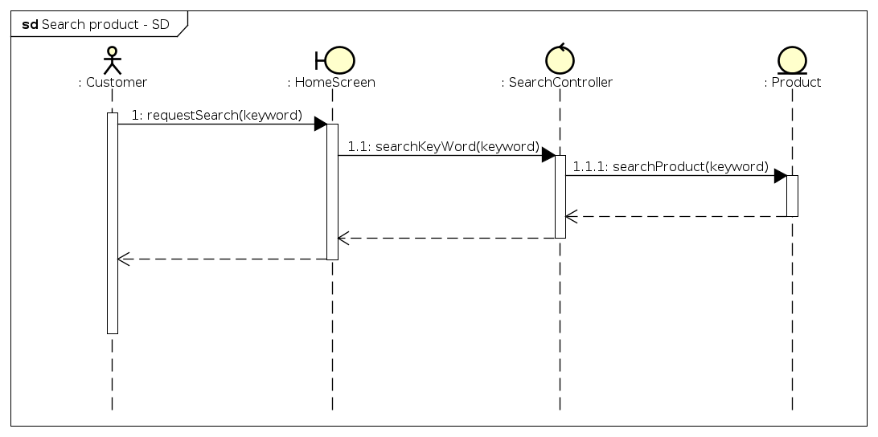
- Update Cart
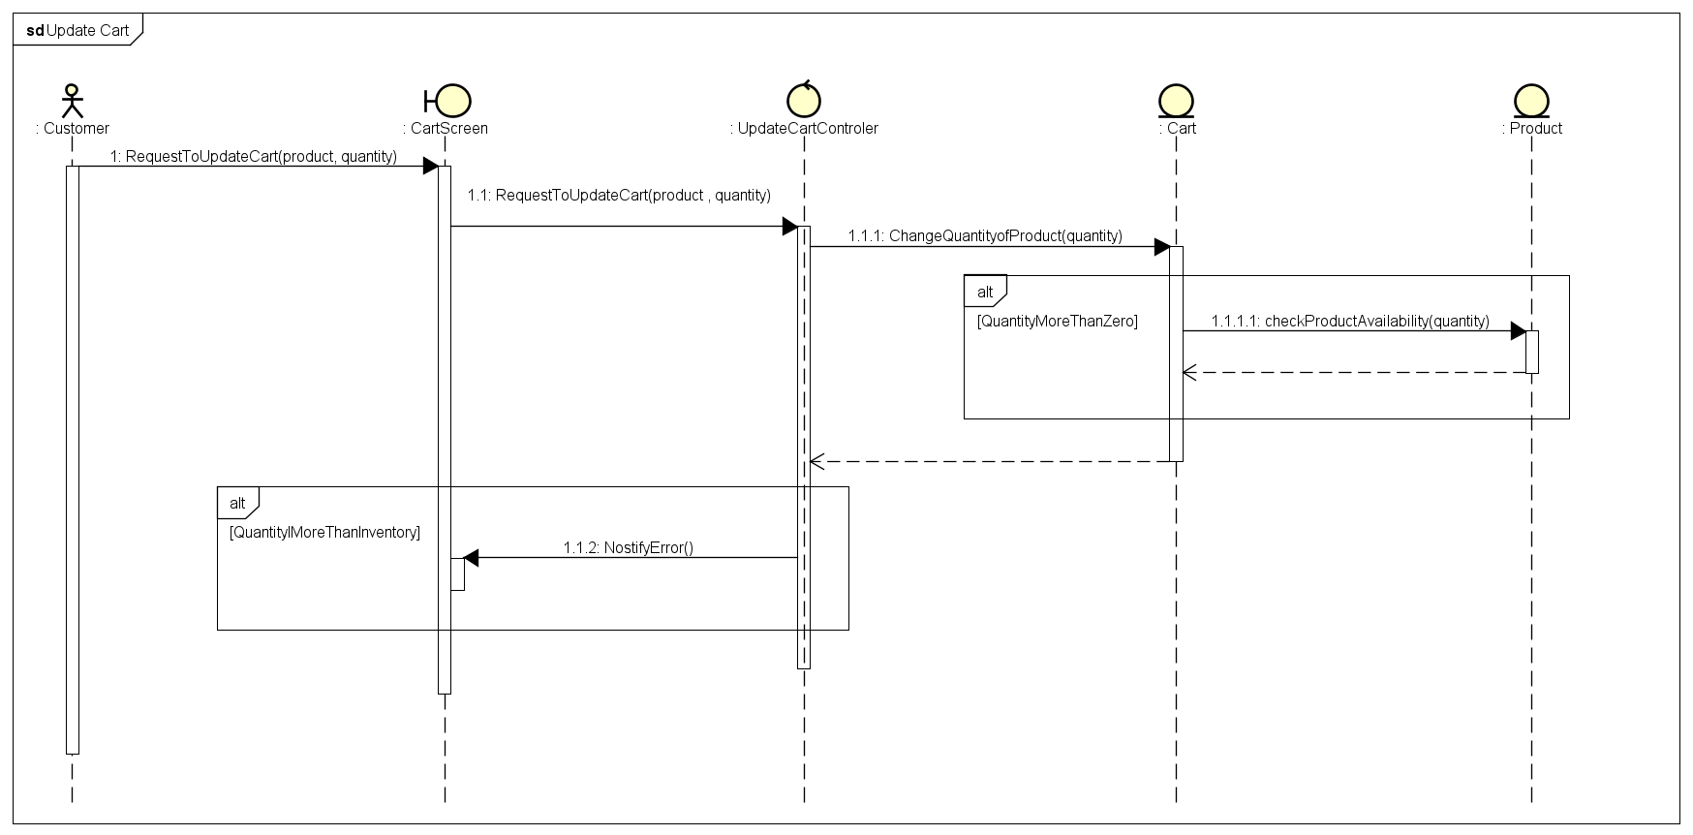
- Update Products
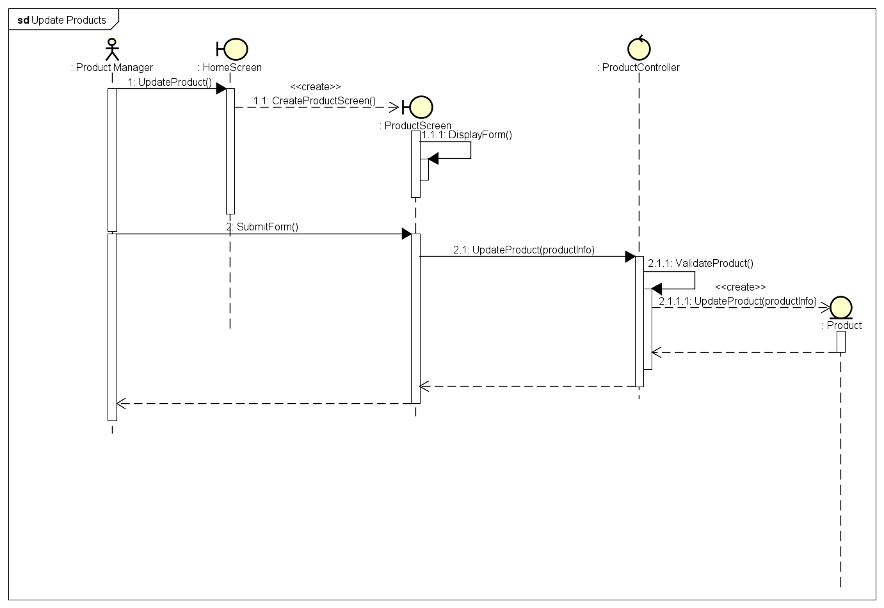
- Update User
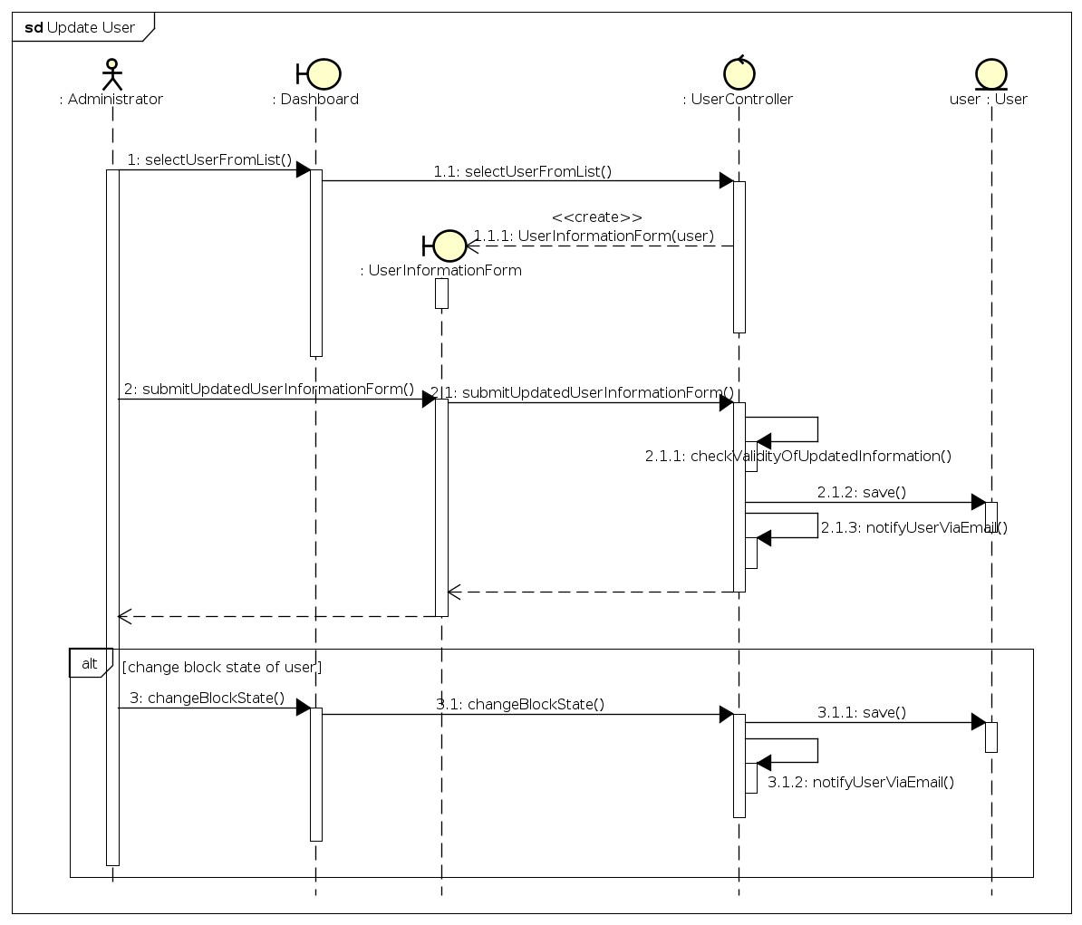
- View cart
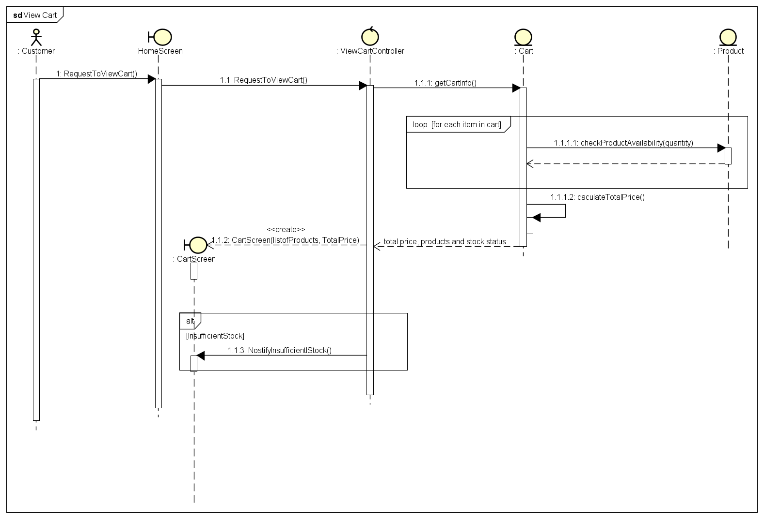
- View Product Details - Customer
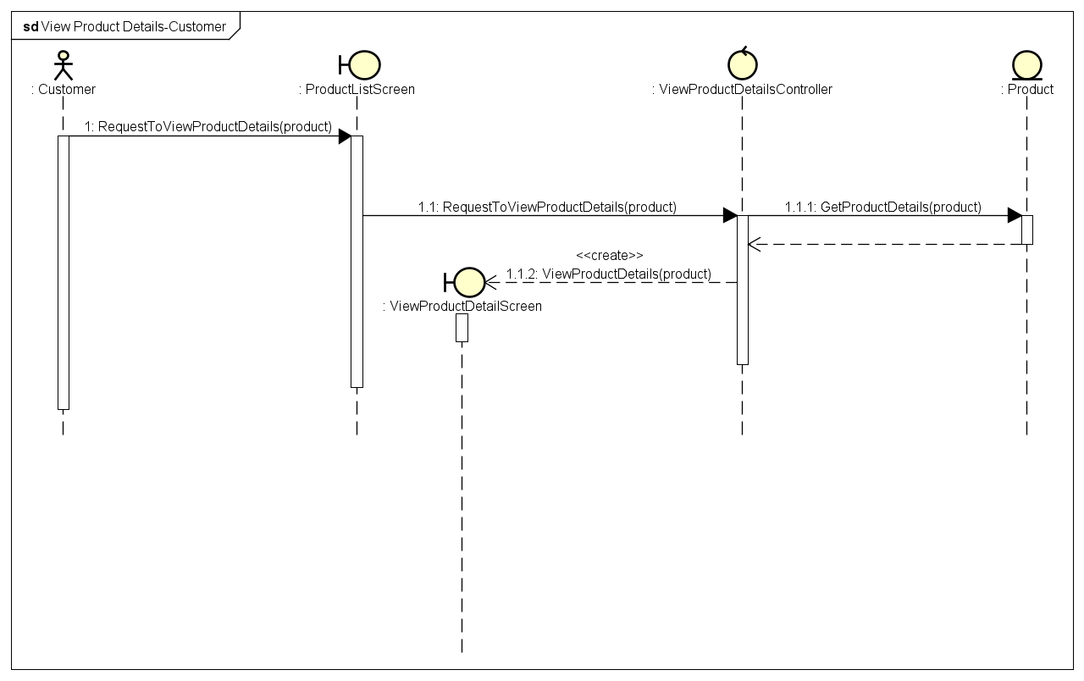
- View Product Details – Manager
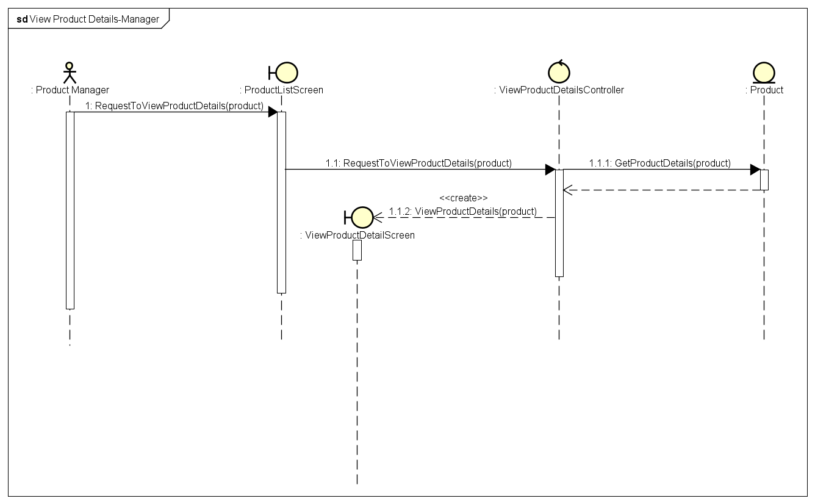

Analysis Class Diagrams
- Add Products to Cart
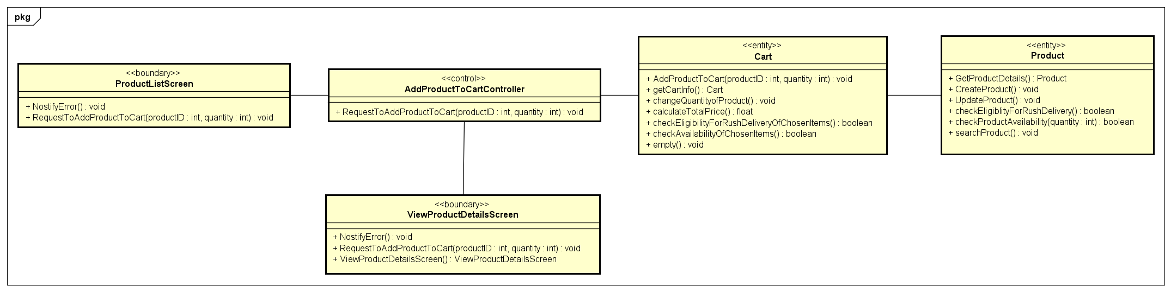
- Add Products
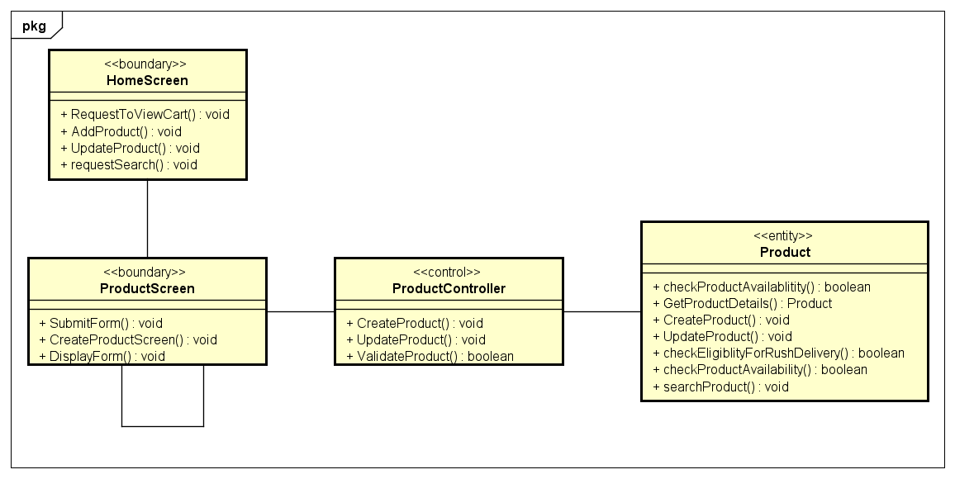
- Cancel Order
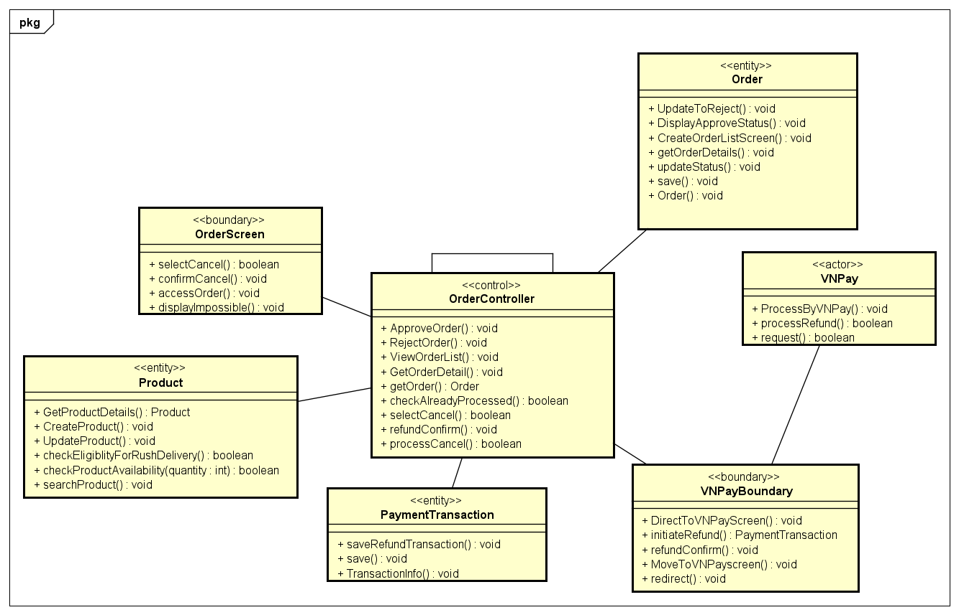
- Create New User
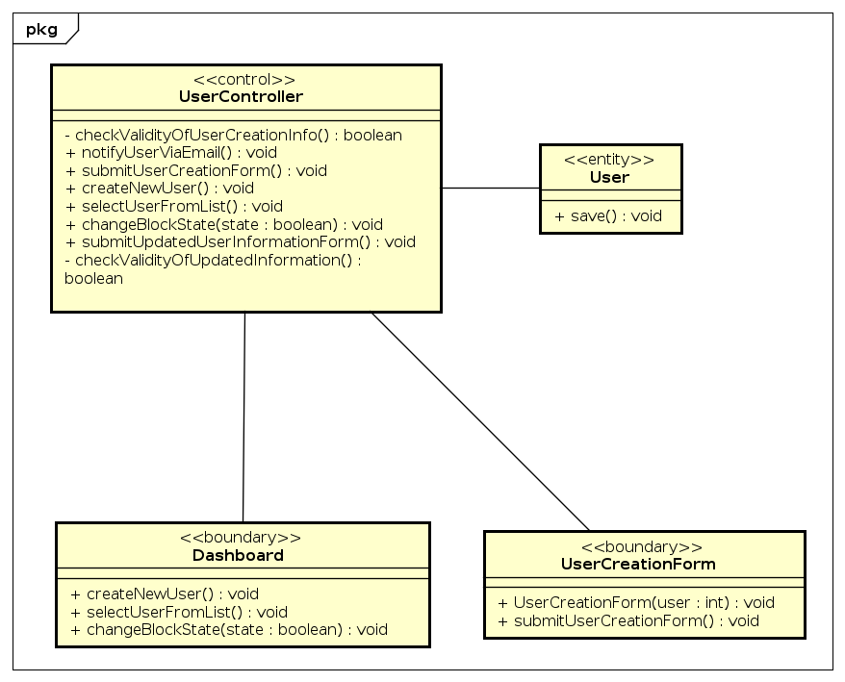
- Pay Order
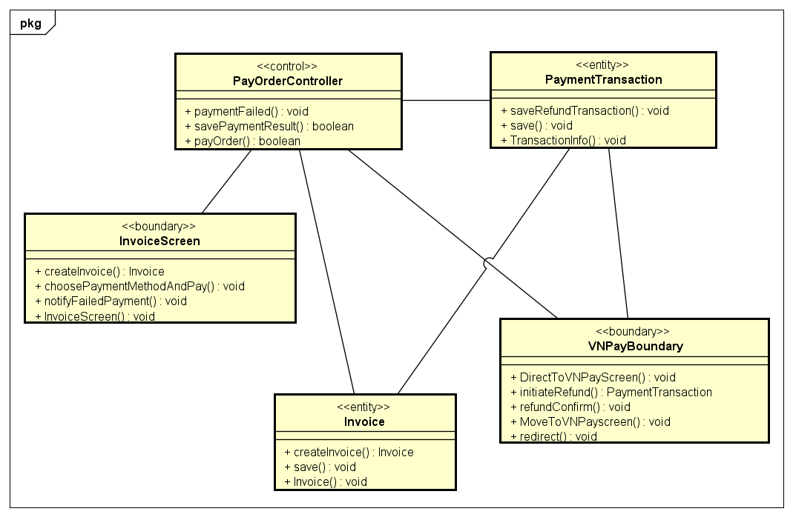
- Place Order
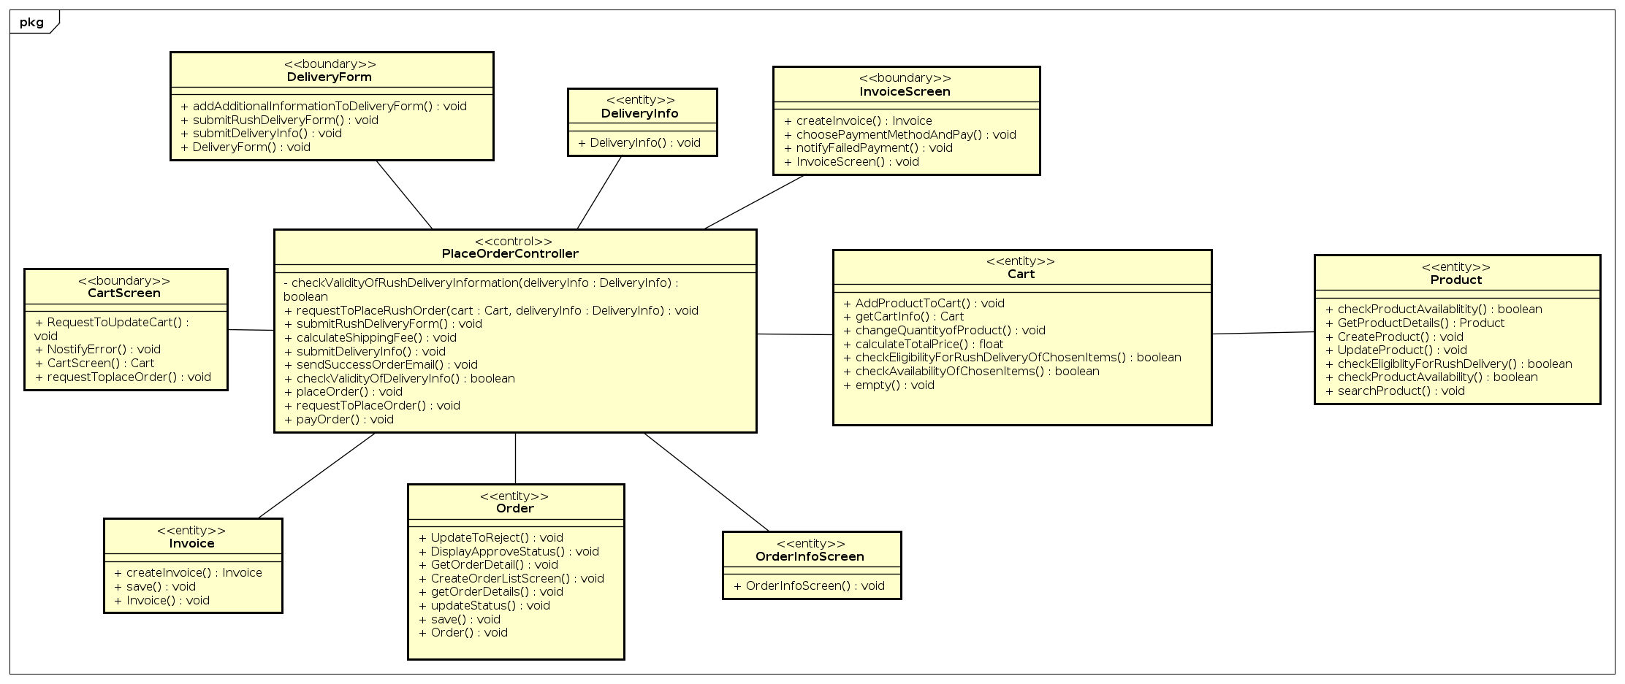
- Place Rush Order
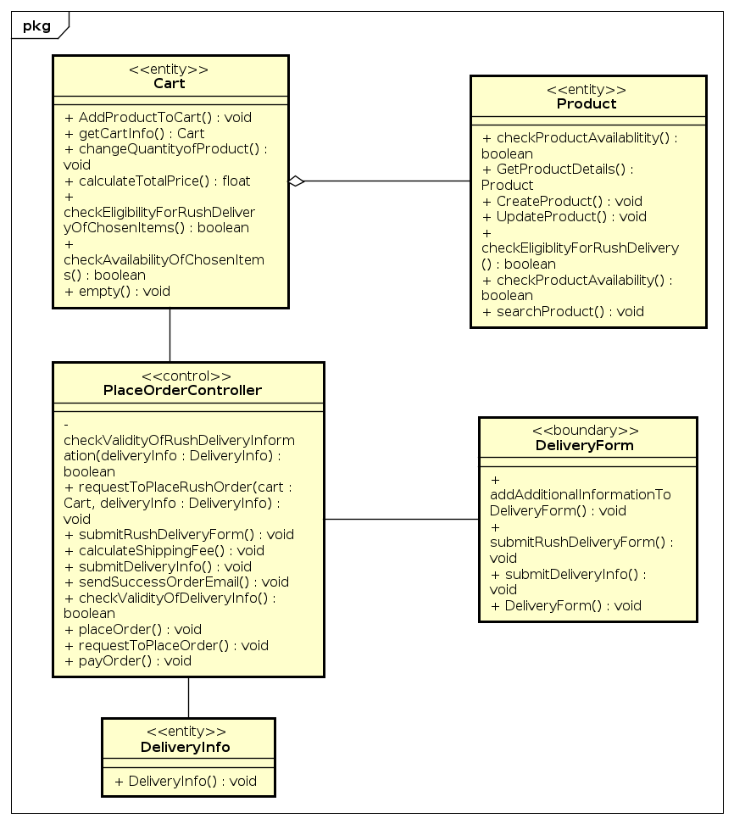
- Process pending order
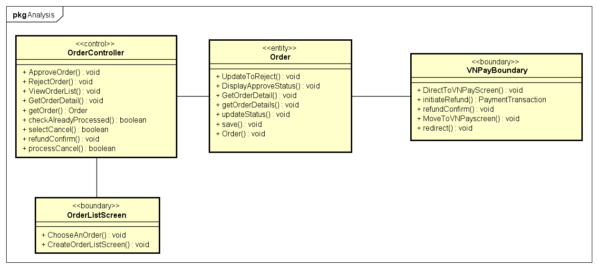
- Search Products
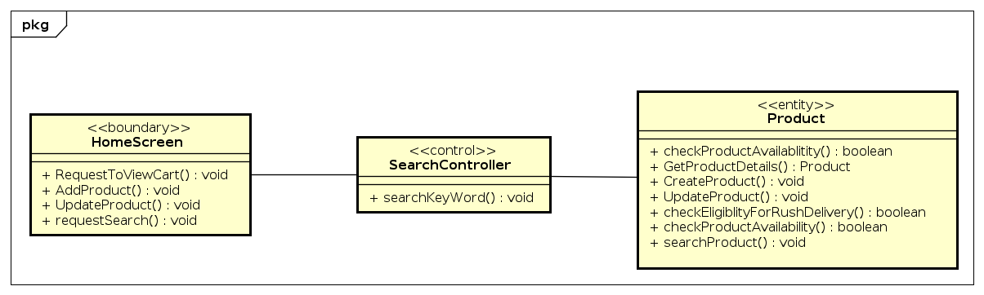
- Update Cart
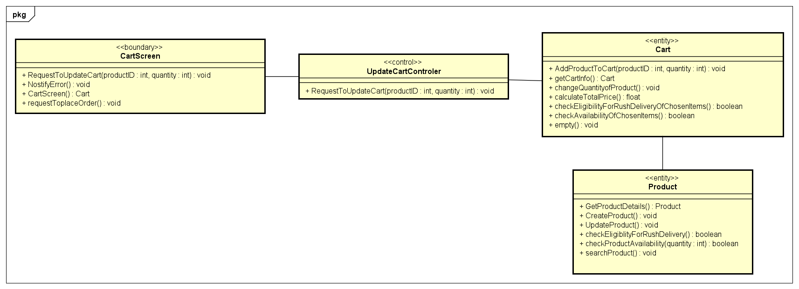
- Update Products
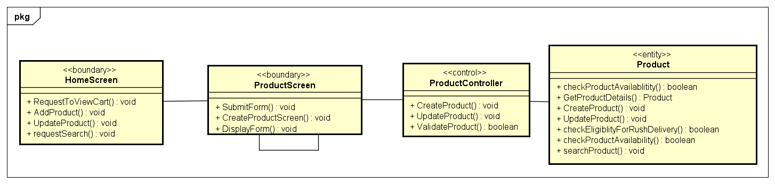
- Update User
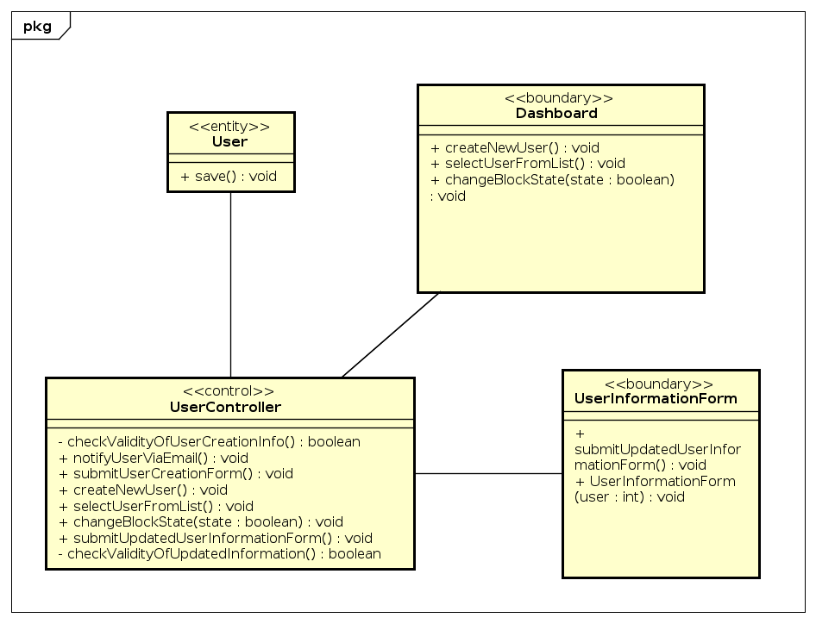
- View Cart
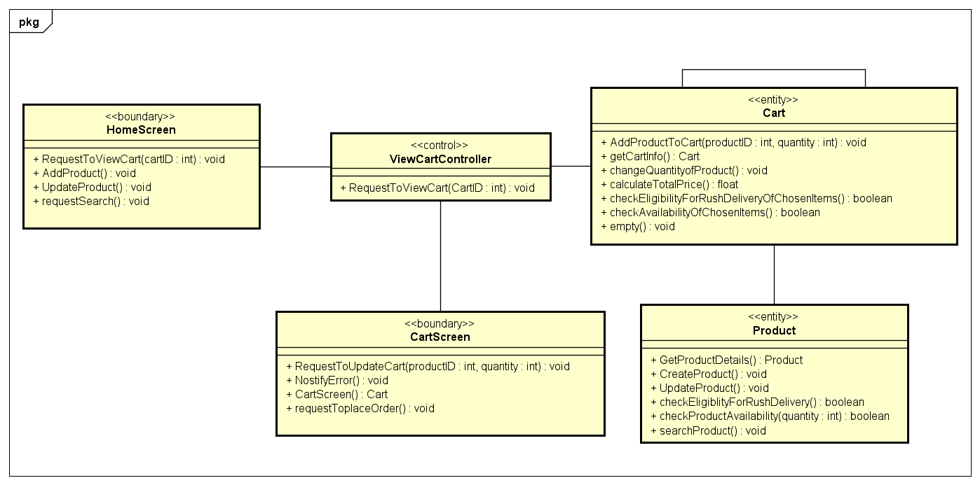
- View Product Details
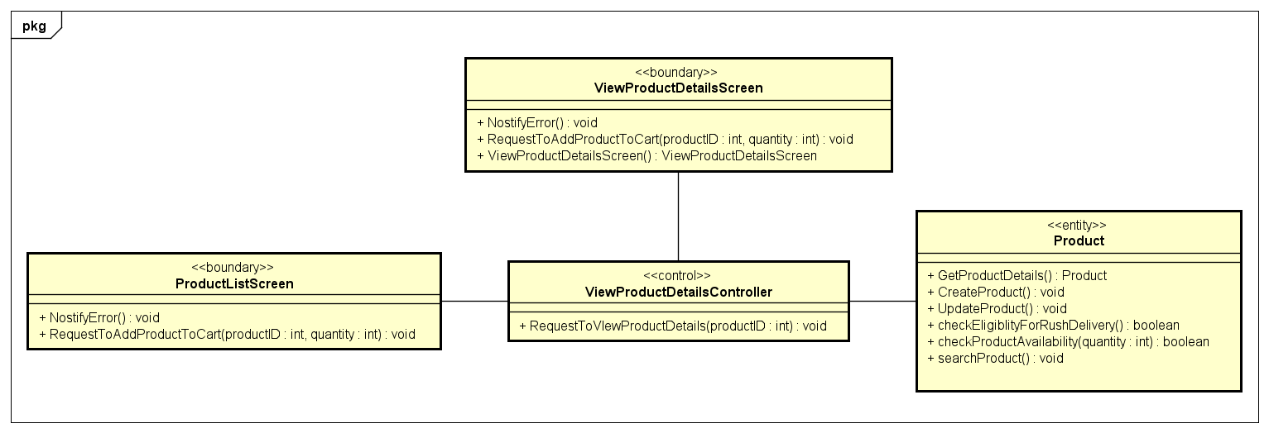

Unified Analysis Class Diagram
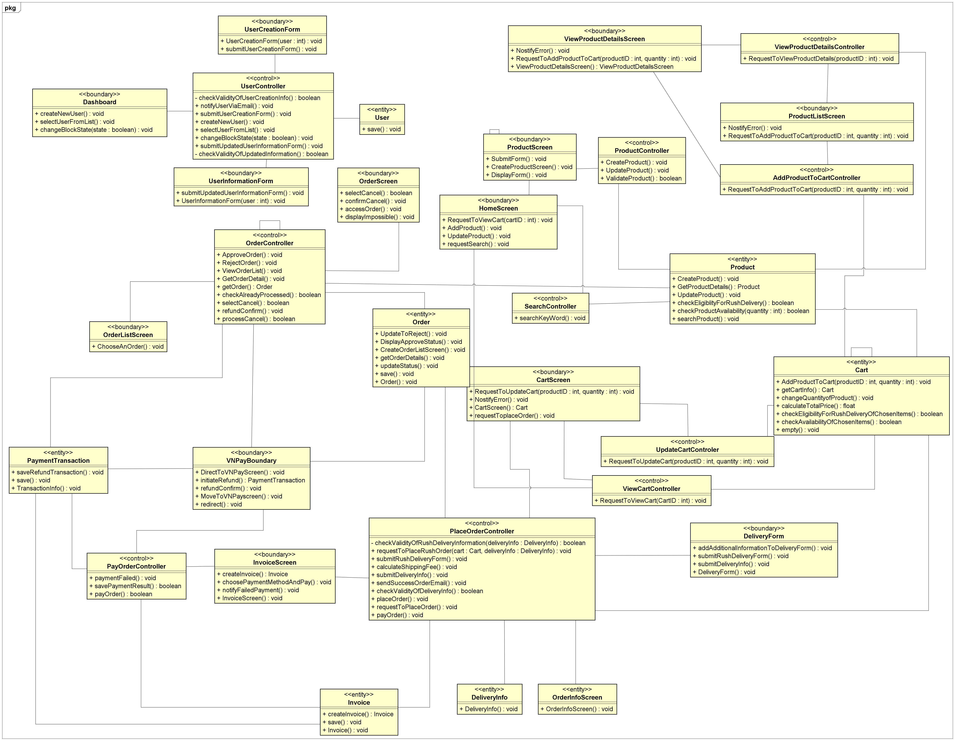

Security Software Architecture
In a three-tier e-commerce setup built with ReactJS on the frontend and Spring Boot on the backend, combining HTTPS and JWT creates a strong security baseline. HTTPS encrypts all traffic between client and server, preventing interception or tampering. Meanwhile, JWT delivers a stateless, trustworthy way to authenticate users and control access.
a. Presentation Tier (ReactJS)
The React application enforces HTTPS for every API call—redirecting any HTTP requests and relying on a valid SSL/TLS certificate on the server. After a successful login, the backend issues a signed JWT that the client stores securely (for example, in local storage or an HTTP-only cookie). All subsequent requests include this token in the Authorization: Bearer <token> header to prove the user’s identity.
b. Business Logic Tier (Spring Boot)
Spring Boot also requires HTTPS on all endpoints, redirecting HTTP and using a proper SSL/TLS setup. On login, it creates a JWT containing user ID, roles, and expiry, signed with a secret or key pair. For protected routes, it verifies the token’s signature and claims, enforces role-based access controls based on those claims, and checks expiration. A refresh mechanism issues new access tokens when old ones expire, preserving session continuity without forcing users to log in repeatedly.
c. Data Access Tier (Database)
Although encryption and tokens operate above the database layer, they ensure only authenticated and authorized requests reach it. To protect data at rest, passwords are hashed (e.g., bcrypt), and any payment details are stored as tokens from a payment gateway rather than raw card numbers. You can further encrypt sensitive fields (like emails or addresses) using AES-256. Access controls drawn from JWT claims ensure that queries return only the data the calling user is permitted to see.
Together, HTTPS and JWT in this architecture guarantee that all data moving between React and Spring Boot remains confidential and tamper-proof, while authentication stays efficient and stateless providing a secure, reliable foundation for your e-commerce platform.

Detailed Design

User Interface Design
<Suppose that you design a Graphical User Interface (GUI)>

Screen Configuration Standardization

Screen Transition Diagrams

Screen Specifications
<Screen images should be included in the screen specifications>

Data Modeling

Conceptual Data Modeling
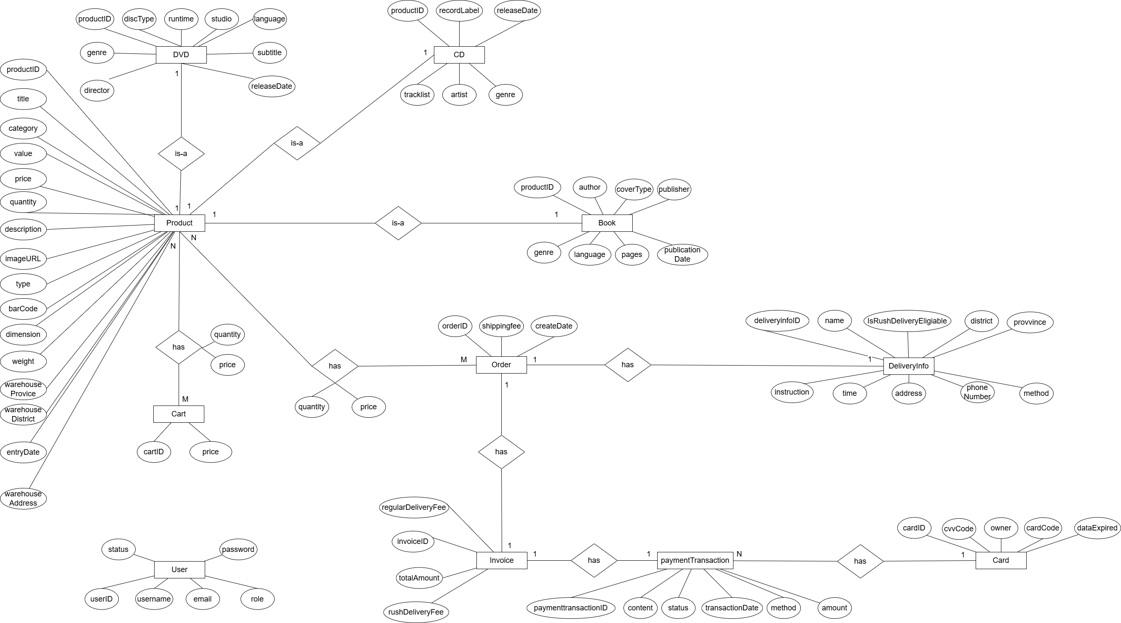

Database Design

Database Management System
We decide to use SQLite as Database Management System.
SQLite3 is a lightweight, serverless, self-contained RDBMS that stores all data in a single file. It's ideal for mobile apps, embedded systems, and applications requiring fast, low-overhead data management. It offers ACID compliance and cross-platform support.

Database Diagram
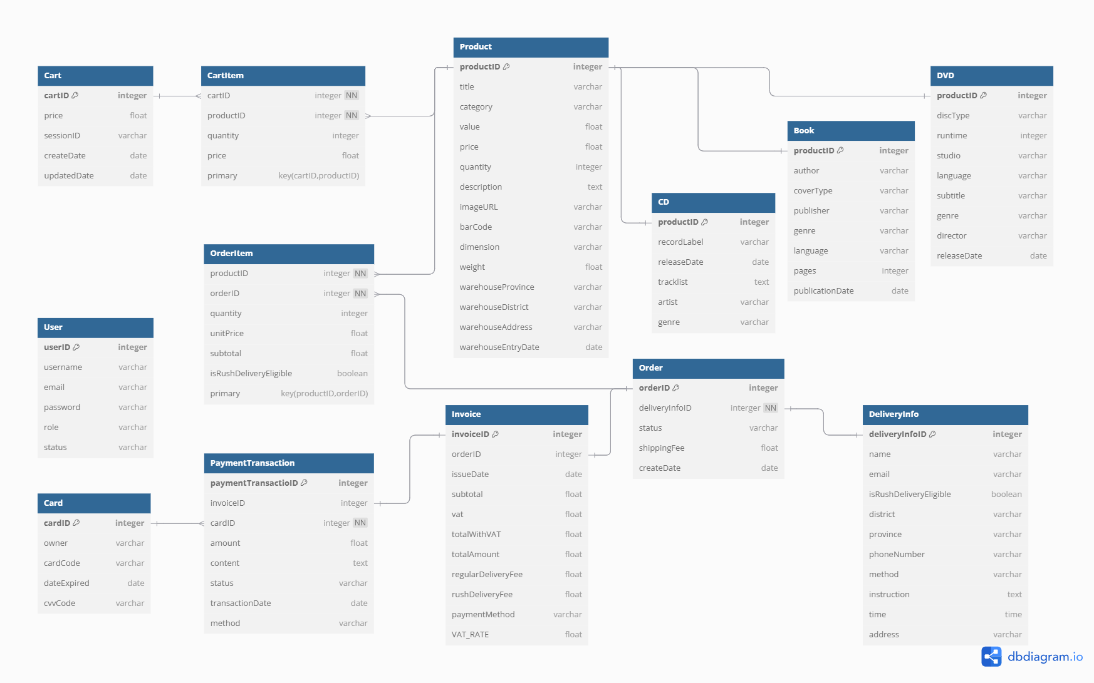

Database Detail Design
Table 1. Product
# | PK | FK | Column Name | Data type | Mandatory | Description
1 | x |  | productID | Integer | Yes | ID, auto increment
2 |  |  | title | VARCHAR | Yes | Name of the product
3 |  |  | category | VARCHAR | Yes | Product category (Book, CD, DVD, or LP record)
4 |  |  | value | FLOAT | Yes | Base price of the product before VAT
5 |  |  | price | FLOAT | Yes | Selling price of the product
6 |  |  | quantity | Integer | Yes | Available quantity in stock
7 |  |  | description | VARCHAR | No | Product description
8 |  |  | imageURL | VARCHAR | No | The URL for the image of the product item
9 |  |  | barCode | VARCHAR | No | Unique barcode for the product
10 |  |  | warehouseEntryDate | DATE | No | Date when the product entered the warehouse
11 |  |  | dimensions | VARCHAR | No | Physical dimensions (e.g., 10x20x5 cm)
12 |  |  | weight | FLOAT | No | Weight in kilograms
13 |  |  | warehouseProvince | VARCHAR | No | Province of warehouse storing the product
14 |  |  | warehouseDistrict | VARCHAR | No | District of warehouse storing the product
15 |  |  | warehouseAddress | VARCHAR | No | Detailed address of warehouse storing the product

Table 2. CD
# | PK | FK | Column Name | Data type | Mandatory | Description
1 |  | x | productID | INTEGER | Yes | ID, same as ID of Product of which type is CD
2 |  |  | artist | VARCHAR(100) | Yes | Name of the artist or band
3 |  |  | recordLabel | VARCHAR(100) | Yes | Name of the record label
4 |  |  | tracklist | VARCHAR(1000) | No | List of tracks in the CD
5 |  |  | genre | VARCHAR(100) | Yes | Music genre of the CD
6 |  |  | releaseDate | DATE | Yes | Official release date of the CD

Table 3. Book
# | PK | FK | Column Name | Data type | Mandatory | Description
1 |  | x | productID | INTEGER | Yes | ID, same as ID of Product of which type is Book
2 |  |  | author | VARCHAR(100) | Yes | Author of the book
3 |  |  | coverType | VARCHAR(45) | Yes | Type of cover (paperback or hardcover)
4 |  |  | publisher | VARCHAR(100) | Yes | Publisher of the book
5 |  |  | publicationDate | DATE | Yes | Date of publication
6 |  |  | pages | INTEGER | Yes | Number of pages
7 |  |  | language | VARCHAR(45) | Yes | Language of the book
8 |  |  | genre | VARCHAR(100) | Yes | Genre of the book
Table 4. DVD
# | PK | FK | Column Name | Data type | Mandatory | Description
1 |  | x | productID | INTEGER | Yes | ID, same as ID of Product of which type is DVD
2 |  |  | discType | VARCHAR(45) | Yes | Type of disc (e.g: Blu-ray, HD-DVD)
3 |  |  | director | VARCHAR(100) | Yes | Name of the artist
4 |  |  | runtime | VARCHAR(20) | Yes | Total runtime of the DVD
5 |  |  | studio | VARCHAR(100) | Yes | Name of the studio
6 |  |  | language | VARCHAR(45) | Yes | Language of the content in DVD
7 |  |  | subtitle | VARCHAR(45) | Yes | Language subtitle
8 |  |  | releaseDate | DATE | Yes | Release date of the DVD
9 |  |  | genre | VARCHAR(100) | Yes | The genre of the DVD

Table 5. DeliveryInfo
# | PK | FK | Column Name | Data type | Mandatory | Description
1 | x |  | deliveryinfoID | INTEGER | Yes | ID, auto increment
2 |  |  | recipientName | VARCHAR(100) | Yes | Name of the recipient
3 |  |  | email | VARCHAR(100) | Yes | Email address
4 |  |  | phoneNumber | VARCHAR(20) | Yes | Phone number
5 |  |  | province | VARCHAR(45) | Yes | Province/city
6 |  |  | district | VARCHAR(45) | Yes | District
7 |  |  | address | VARCHAR(200) | Yes | Delivery address
8 |  |  | deliveryMethod | VARCHAR(20) | Yes | Delivery method (Regular/Rush)
9 |  |  | deliveryTime | FLOAT | No | Requested time for rush delivery
10 |  |  | isRushDeliveryEligible | BOOLEAN | Yes | Indicates if address is eligible for rush delivery
11 |  |  | deliveryInstructions | VARCHAR(255) | No | Special delivery instructions

Table 6. Invoice
# | PK | FK | Column Name | Data type | Mandatory | Description
1 | x |  | invoiceID | INTEGER | Yes | Unique Identifier for the invoice
2 |  | x | orderID | INTEGER | Yes | Order associated with this invoice (FK to Order)
3 |  |  | issueDate | DATE | Yes | Date when invoice was created
4 |  |  | subtotal | FLOAT | Yes | Total price excluding VAT
5 |  |  | VAT | FLOAT | Yes | Value Added Tax amount (10% of subtotal)
6 |  |  | totalWithVAT | FLOAT | Yes | Subtotal + VAT
7 |  |  | regularDeliveryFee | FLOAT | Yes | Fee for regular delivery items
8 |  |  | rushDeliveryFee | FLOAT | Yes | Fee for rush delivery items
9 |  |  | totalAmount | FLOAT | Yes | Final amount to be paid
10 |  |  | paymentMethod | VARCHAR(45) | Yes | Method of payment
11 |  |  | VAT_RATE | FLOAT | Yes | Value-added tax rate (constant 10%)

Table 7. Payment Transaction
# | PK | FK | Column Name | Data type | Mandatory | Description
1 | x |  | transactionID | INTEGER | Yes | Unique Identifier for the transaction
2 |  |  | amount | FLOAT | Yes | Payment amount
3 |  |  | paymentMethod | VARCHAR(45) | Yes | Method of payment
4 |  |  | transactionDate | DATE | Yes | Date of transaction
5 |  |  | status | VARCHAR(20) | Yes | Transaction status (Pending, Success, Failed…)
6 |  |  | content | VARCHAR(255) | No | Transaction details
7 |  | x | cardID | INTEGER | Yes | ID of used card
8 |  | x | invoiceID | INTEGER | Yes | FK to Invoice

Table 8. User
# | PK | FK | Column Name | Data type | Mandatory | Description
1 | x |  | userID | INTEGER | Yes | Randomly auto-generated, exclusive
2 |  |  | username | VARCHAR(50) | Yes | Exclusively exists to identify users using the software
3 |  |  | email | VARCHAR(100) | No | Saved when using Gmail for registration
4 |  |  | password | VARCHAR(255) | Yes | Must be hashed before stored into database
5 |  |  | role | VARCHAR(45) | Yes | User role (Administrator / Product Manager)
6 |  |  | status | BOOLEAN | Yes | True = Unblocked, False = Blocked

Table 9. Order
# | PK | FK | Column Name | Data type | Mandatory | Description
1 | x |  | orderID | INTEGER | Yes | Unique identifier for the order
2 |  |  | status | VARCHAR | Yes | Current status: "pending," "approved," "rejected," "canceled”.
3 |  |  | shippingFee | FLOAT | Yes | Calculated VAT amount (10% of subtotal)
4 |  | x | deliveryInfoID | INTEGER | Yes | Reference to delivery information (FK to DeliveryInfo)

Table 10. OrderItem
# | PK | FK | Column Name | Data type | Mandatory | Description
1 | x | x | orderID | INTEGER | Yes | Reference to the order (FK to Order)
2 | x | x | productID | INTEGER | Yes | ID of the product in the order
3 |  |  | quantity | INTEGER | Yes | Quantity of the product ordered
4 |  |  | unitPrice | FLOAT | Yes | Price of the product at time of order
5 |  |  | subtotal | FLOAT | Yes | Total price for this item (unitPrice × quantity)
6 |  |  | isRushDeliveryEligible | BOOLEAN | Yes | Whether this item is eligible for rush delivery
7 |  |  | weight | FLOAT | No | Weight of one unit of this product

Table 11. Cart
# | PK | FK | Column Name | Data type | Mandatory | Description
1 | x |  | cartID | INTEGER | Yes | Unique identifier for the cart
2 |  |  | sessionID | VARCHAR | Yes | Identifier for the user's session
3 |  |  | createdDate | DATE | Yes | Date when the cart was created
4 |  |  | updatedDate | DATE | Yes | Date when the cart was last updated

Table 12. CartItem
# | PK | FK | Column Name | Data type | Mandatory | Description
1 | X | X | cartID | INTEGER | Yes | ID of the cart containing this item
2 | X | X | productID | INTEGER | Yes | ID of the product in the cart
3 |  |  | quantity | INTEGER | Yes | Quantity of the product
4 |  |  | price | FLOAT | Yes | Selling price of the product

Table 13. Card
# | PK | FK | Column Name | Data type | Mandatory | Description
1 | x |  | cardID | INTEGER | Yes | Unique identifier for the card
2 |  |  | cardCode | VARCHAR | Yes | Credit card number
3 |  |  | owner | VARCHAR | Yes | Name of the cardholder
4 |  |  | cvvCode | VARCHAR | Yes | Card verification value/code
5 |  |  | dataExpired | DATE | Yes | Expiration date of the card

SQLite3 scripts to create database for AIMS project ---
CREATE TABLE "Product" ( "productID" INTEGER PRIMARY KEY AUTOINCREMENT NOT NULL, "title" TEXT NOT NULL, "category" TEXT NOT NULL, "value" REAL NOT NULL, "price" REAL NOT NULL, "quantity" INT NOT NULL DEFAULT 0, "description" TEXT, "imageURL" TEXT NOT NULL, "barCode" TEXT, "warehouseEntryDate" DATE DEFAULT CURRENT_DATE, "dimensions" TEXT, "weight" REAL, "warehouseProvince" TEXT, "warehouseDistrict" TEXT, "warehouseAddress" TEXT, "createdAt" DATETIME DEFAULT CURRENT_TIMESTAMP, "updatedAt" DATETIME DEFAULT CURRENT_TIMESTAMP );
CREATE TABLE "CD"( "productID" INTEGER PRIMARY KEY NOT NULL, "artist" TEXT NOT NULL, "recordLabel" TEXT NOT NULL, "tracklist" TEXT, "genre" TEXT NOT NULL, "releasedDate" DATE, CONSTRAINT "fk_CD_Product1" FOREIGN KEY("productID") REFERENCES "Product"("productID") );
CREATE TABLE "Book"( "productID" INTEGER PRIMARY KEY NOT NULL, "author" TEXT NOT NULL, "coverType" TEXT NOT NULL, "publisher" TEXT NOT NULL, "publicationDate" DATE NOT NULL, "numOfPages" INTEGER NOT NULL, "language" TEXT NOT NULL, "genre" TEXT NOT NULL, CONSTRAINT "fk_Book_Product1" FOREIGN KEY("productID") REFERENCES "Product"("productID") );
CREATE TABLE "DVD" ( "productID" INTEGER PRIMARY KEY NOT NULL, "discType" TEXT NOT NULL, "director" TEXT NOT NULL, "runtime" TEXT NOT NULL, "studio" TEXT NOT NULL, "language" TEXT NOT NULL, "subtitle" TEXT NOT NULL, "releaseDate" DATE NOT NULL, "genre" TEXT NOT NULL, CONSTRAINT "fk_DVD_Product1" FOREIGN KEY ("productID") REFERENCES "Product"("productID") );
CREATE TABLE "DeliveryInfo" ( "deliveryInfoID" INTEGER PRIMARY KEY AUTOINCREMENT, "recipientName" TEXT NOT NULL, "email" TEXT NOT NULL, "phoneNumber" TEXT NOT NULL, "province" TEXT NOT NULL, "district" TEXT NOT NULL, "address" TEXT NOT NULL, "deliveryMethod" TEXT NOT NULL, "deliveryTime" REAL, "isRushDeliveryEligible" BOOLEAN NOT NULL, "deliveryInstructions" TEXT, "createdAt" DATETIME DEFAULT CURRENT_TIMESTAMP, "updatedAt" DATETIME DEFAULT CURRENT_TIMESTAMP );
CREATE TABLE "Card"( "cardID" INTEGER PRIMARY KEY AUTOINCREMENT NOT NULL, "cardCode" TEXT NOT NULL, "owner" TEXT NOT NULL, "cvvCode" TEXT NOT NULL, "dateExpired" TEXT NOT NULL );
CREATE TABLE "User" ( "userID" INTEGER PRIMARY KEY AUTOINCREMENT NOT NULL, "username" TEXT NOT NULL UNIQUE, "email" TEXT NOT NULL, "password" TEXT NOT NULL, "role" TEXT NOT NULL, "status" BOOLEAN NOT NULL, "createdAt" DATETIME DEFAULT CURRENT_TIMESTAMP, "updatedAt" DATETIME DEFAULT CURRENT_TIMESTAMP );
CREATE TABLE "Cart" ( "cartID" INTEGER PRIMARY KEY AUTOINCREMENT NOT NULL, "sessionID" TEXT, "createdAt" DATETIME DEFAULT CURRENT_TIMESTAMP );
CREATE TABLE "CartItem" ( "cartID" INTEGER NOT NULL, "productID" INTEGER NOT NULL, "quantity" INTEGER NOT NULL, "price" REAL NOT NULL, PRIMARY KEY ("cartID", "productID"), FOREIGN KEY ("cartID") REFERENCES "Cart"("cartID"), FOREIGN KEY ("productID") REFERENCES "Product"("productID") );
CREATE TABLE "Order" ( "orderID" INTEGER PRIMARY KEY AUTOINCREMENT NOT NULL, "status" CHARACTER(15) NOT NULL, "shippingFee" REAL NOT NULL, "deliveryInfoID" INTEGER NOT NULL, FOREIGN KEY ("deliveryInfoID") REFERENCES "DeliveryInfo"("deliveryInfoID") );
CREATE TABLE "OrderItem" ( "orderID" INTEGER NOT NULL, "productID" INTEGER NOT NULL, "quantity" INTEGER NOT NULL, "unitPrice" REAL NOT NULL, "subtotal" REAL NOT NULL, "isRushDeliveryEligible" BOOLEAN NOT NULL, "weight" REAL, PRIMARY KEY ("orderID", "productID"), FOREIGN KEY ("orderID") REFERENCES "Order"("orderID"), FOREIGN KEY ("productID") REFERENCES "Product"("productID") );
CREATE TABLE "Invoice" ( "invoiceID" INTEGER PRIMARY KEY AUTOINCREMENT NOT NULL, "orderID" INTEGER NOT NULL, "issueDate" DATE NOT NULL, "subtotal" REAL NOT NULL, "VAT" REAL NOT NULL, "totalWithVAT" REAL NOT NULL, "regularDeliveryFee" REAL NOT NULL, "rushDeliveryFee" REAL NOT NULL, "totalAmount" REAL NOT NULL, "paymentMethod" TEXT NOT NULL, "VAT_RATE" REAL NOT NULL, FOREIGN KEY ("orderID") REFERENCES "Order"("orderID") );
CREATE TABLE "PaymentTransaction" ( "transactionID" INTEGER PRIMARY KEY AUTOINCREMENT NOT NULL, "amount" REAL NOT NULL, "paymentMethod" TEXT NOT NULL, "transactionDate" DATE NOT NULL, "status" TEXT NOT NULL, "content" TEXT, "cardID" INTEGER NOT NULL, "invoiceID" INTEGER NOT NULL, FOREIGN KEY ("cardID") REFERENCES "Card"("cardID"), FOREIGN KEY ("invoiceID") REFERENCES "Invoice"("invoiceID") );
CREATE INDEX "idx_product_category" ON "Product"("category"); CREATE INDEX "idx_product_title" ON "Product"("title"); CREATE INDEX "idx_order_status" ON "Order"("status");
CREATE TRIGGER "product_updatedAt_tg" AFTER UPDATE ON "Product" BEGIN UPDATE "Product" SET "updatedAt" = DATETIME('NOW', 'localtime') WHERE "productID" = OLD."productID"; END;
CREATE TRIGGER "user_updatedAt_tg" AFTER UPDATE ON "User" FOR EACH ROW BEGIN UPDATE "User" SET "updatedAt" = DATETIME('NOW', 'localtime') WHERE "userID" = OLD."userID"; END;

Non-Database Management System Files
<Provide the detailed description of all non-DBMS files if any and include a narrative description of the usage of each file that identifies if the file is used for input, output, or both, and if the file is a temporary file. Also provide an indication of which modules read and write the file and include file structures (refer to the data dictionary). As appropriate, the file structure information should include the following:
• Record structures, record keys or indexes, and data elements referenced within the records
• Record length (fixed or maximum variable length) and blocking factors
• Access method (e.g., index sequential, virtual sequential, random access, etc.)
• Estimate of the file size or volume of data within the file, including overhead resulting from file access methods
• Definition of the update frequency of the file (If the file is part of an online transaction-based system, provide the estimated number of transactions per unit of time, and the statistical mean, mode, and distribution of those transactions.)
• Backup and recovery specifications>
The group has worked on

Class Design

General Class Diagram
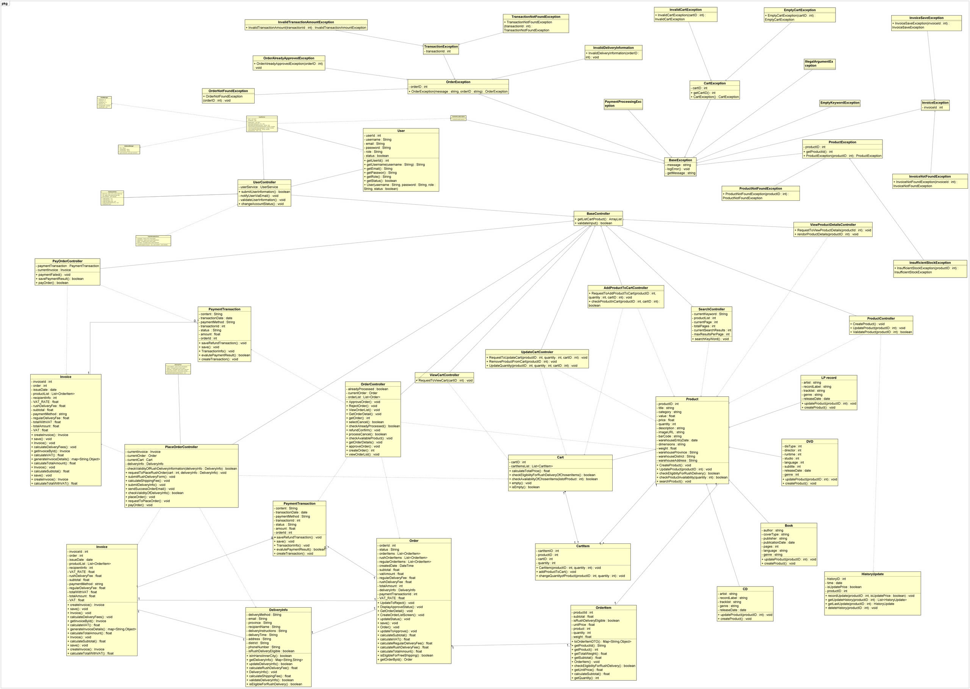

Class Diagrams
4.5.2.1. Package 'model'

4.5.2.2. Package 'service'

4.5.2.3. Package 'controller'
4.5.2.4. Package 'view'
4.5.2.5. Package 'utils'
4.5.2.6. Package 'exception

Class Design
<Detail design for each class>

Class “Product”
<SampleClass1 class image in UML>
Table 2. Example of attribute design
# | Name | Data type | Default value | Description
1 | productId | int | null | Unique Identifier for the product
2 | title | String | null | Name of the product
3 | category | String | null | Product category (Book, CD, DVD, or LP record)
4 | value | float | 0.0 | Base price of the product before VAT
5 | price | float | 0.0 | Selling price of the product
6 | quantity | int | 0 | Available quantity in stock
7 | description | String | null | Product description
8 | imageURL | String | null | The URL for the image of the product item
9 | barCode | String | null | Unique barcode for the product
10 | warehouseEntryDate | Date | null | Date when the product entered the warehouse
11 | dimensions | String | null | Physical dimensions of the product (e.g., 10x20x5 cm)
12 | weight | float | null | Weight of the product in kilograms
13 | warehouseProvince | String | null | province of warehouse storing the product
14 | warehouseDistrict | String | null | district of warehouse storing the product
15 | warehouseAddress | String | null | detailed address of warehouse storing the product

Table 3. Example of operation design
# | Name | Return type | Description (purpose)
1 | checkProductAvailability | boolean | Checks if the product has sufficient quantity available
2 | updateProduct | voId | Updates product information in the system
3 | checkEligibilityOfRushDelivery | boolean | Checks if product is eligible for rush delivery
4 | createProduct | voId | Create a new product in the system
5 | searchProduct | voId | Search for a specific product attributes

Parameter:

checkProductAvailability( quantity: int): Boolean

quantity: An integer representing the number of products to check if the available inventory is sufficient.

Return: true if the available inventory is sufficient, otherwise false.

updateProduct(productId: int): voId

productId: productId must exist

searchProduct(searchCriteria: Map<String, Object>): voId

searchCriteria: A map containing search criteria (field names and values)

Exception:

updateProduct(productId: int): voId

ProductNotFoundException: If no product with the specified productId is found.

ExceedUpdateTimesException: If update more than 30 products a day

ExceedUpdatePriceTimesPerDayException: If update price more than twice a day

Method:

- How to use parameters/attributes:

checkProductAvailability(quantity: int): Boolean

Purpose: This method checks whether the available inventory is sufficient for the requested quantity of a product.

Usage: If the available stock is at least equal to the requested quantity, the method returns true; otherwise, it returns false.

updateProduct(productId: int): voId

Purpose: This method updates the details of an existing product based on the provIded information.

Usage: If the product exists, the method updates attributes such as name, price, quantity, etc

createProduct(): voId

Purpose: This method creates a new product with the provIded information.

Usage: If all required attributes are provIded and valId, the product is successfully created and added to the inventory.

checkEligibilityOfRushDelivery(address: String): Boolean

Purpose: to check rush delivery support

Usage: compare ‘address’ parameter (from delivery information) and address of product (based on information provIded by Product Manager)

searchProduct(searchCriteria: Map<String, Object>): voId

Purpose: Searches for products matching specific criteria.

Usage: Used to find products based on various attributes.

Processing:

Constructs a database query based on the search criteria

Executes the query

Returns matching products

State:

If stock > requested quantity → Available.

If stock < requested quantity → Not Available.

If product_Id is invalId → ProductNotFoundException is raised.

Class “Book”
Table 1. Attribute design

# | Name | Data type | Default value | Description
1 | author | String | null | Author of the book
2 | coverType | String | null | Type of cover (paperback or hardcover)
3 | publisher | String | null | Publisher of the book
4 | publicationDate | Date | null | Date of publication
5 | pages | int | 0 | Number of pages
6 | language | String | null | Language of the book
7 | genre | String | null | Genre of the book
Table 2. Operation design

# | Name | Return type | Description (purpose)
1 | updateProduct | voId | Updates product information in the system
2 | createProduct | voId | Create a new product in the system
Parameter: None Exception:

updateProduct(productId: int): voId

ExceedUpdatedTimesException: If update more than 30 products a day

ExceedUpdateTimesPerDayException: If update more than twice a day

Method:

How to use parameters/attributes:

updateProduct(productId: int): voId

Purpose: Updates attributes such as price, quantity, and description,.. of book.

Usage: If the book exists, the method updates attributes such as name, price, quantity, etc

createProduct(): voId

Purpose: Creates a new Book with specified attributes such as name, price, stock quantity, and description.

Usage: If all required attributes are provIded and valId, the book is successfully created and added to the inventory.

Class CD
Table 1. Attribute design

# | Name | Data type | Default value | Description
1 | artist | String | null | Name of the artist or band
2 | recordLabel | String | null | Name of the record label
3 | tracklist | String | null | List of tracks in the CD
4 | genre | String | null | Music genre of the CD
5 | releaseDate | Date | 0 | Official release date of the CD
Table 2. Operation design

# | Name | Return type | Description (purpose)
1 | updateProduct | voId | Updates product information in the system
2 | createProduct | voId | Create a new product in the system

Parameter: None Exception:

updateProduct(productId: int): voId

ExceedUpdatedTimesException: If update more than 30 products a day

ExceedUpdateTimesPerDayException: If update more than twice a day

Method:

How to use parameters/attributes:

updateProduct(productId: int): voId

Purpose: Updates attributes such as price, quantity, and description,.. of CD.

Usage: If the CD exists, the method updates attributes such as name, price, quantity, etc

createProduct(): voId

Purpose: Creates a new CD with specified attributes such as name, price, stock quantity, and description.

Usage: If all required attributes are provIded and valId, the CD is successfully created and added to the inventory.

Class DVD
Table 1. Attribute design

# | Name | Data type | Default value | Description
1 | discType | String | null | Type of disc (e.g: Blu-ray, HD-DVD)
2 | director | String | null | Name of the artist
3 | runtime | String | null | Total runtime of the DVD
4 | studio | String | null | Name of the studio
5 | language | String | null | Language of the content in DVD
5 | subtitle | String | null | Language subtitle
6 | releaseDate | Date | null | Release date of the DVD
7 | genre | String | null | The genre of the DVD
Table 2. Operation design

# | Name | Return type | Description (purpose)
1 | updateProduct | voId | Updates product information in the system

2 | createProduct | voId | Create a new product in the system

Parameter: None Exception:

updateProduct(productId: int): voId

ExceedUpdatedTimesException: If update more than 30 products a day

ExceedUpdateTimesPerDayException: If update more than twice a day

Method:

How to use parameters/attributes:

createProduct():

Purpose: Creates a new DVD with specified attributes such as name, price, stock quantity, and description.

Usage: If all required attributes are provIded and valId, the DVD is successfully created and added to the inventory.

updateProduct(productId: int): voId

Purpose: Updates attributes such as price, quantity, and description,.. of DVD.

Usage: If the DVD exists, the method updates attributes such as name, price, quantity, etc

Class LPrecord
Table 1. Attribute design

# | Name | Data type | Default value | Description
1 | artist | String | null | Name of the artist or band
2 | recordLabel | String | null | Name of the record label
3 | tracklist | String | null | List of tracks in the LP record
4 | genre | String | null | Music genre of the LP record
5 | releaseDate | Date | 0 | Official release date of the LP record
Table 2. Operation design

# | Name | Return type | Description (purpose)
1 | updateProduct | voId | Updates product information in the system
2 | createProduct | voId | Create a new product in the system

Parameter: None Exception:

updateProduct(productId: int): voId

ExceedUpdatedTimesException: If update more than 30 products a day

ExceedUpdateTimesPerDayException: If update more than twice a day

Method:

How to use parameters/attributes:

createProduct():

Purpose: Creates a new DVD with specified attributes such as name, price, stock quantity, and description.

Usage: If all required attributes are provIded and valId, the DVD is successfully created and added to the inventory.

updateProduct(productId: int): voId

Purpose: Updates attributes such as price, quantity, and description,.. of DVD.

Usage: If the DVD exists, the method updates attributes such as name, price, quantity, etc

Class History update
Table 1. Atrribute design

# | Name | Data type | Default value | Description
1 | historyId | int | null | Unique Identifier for the product
2 | time | Date | null | The time product manager update the product

3 | isUpdatePrice | boolean | null | The price of the product is update or not
4 | productId | int | null | The Id of the product
Table 2. Operation design

# | Name | Return type | Description (purpose)
1 | recordUpdate | voId | Records the update history of a product when changes are made
2 | getUpdateHistory | List<HistoryUp date> | Retrieves the update history of a product based on productId.
3 | getLastUpdate | HistoryUpdate | Retrieves the most recent update of a product.
4 | deleteHistory | voId | Deletes the entire update history of a product based on productId.

Parameter:

recordUpdate(productId: int, isUpdatePrice: boolean): voId

productId: An integer representing the unique Identifier of the updated product.

isUpdatePrice: A boolean indicating whether the product price was updated.

Return: This method does not return a value. It records an update entry in the history log.

getUpdateHistory(productId: int): List<HistoryUpdate>

productId: An integer representing the unique Identifier of the product.

Return: A list of HistoryUpdate objects containing all update records for the specified product. If no history exists, it returns an empty list.

getLastUpdate(productId: int): HistoryUpdate

productId: An integer representing the unique Identifier of the product.

Return: A HistoryUpdate object containing the latest update details of the specified product. If no update history exists, it returns null or raises an exception.

deleteHistory(productId: int): voId

productId: An integer representing the unique Identifier of the product.

Return: This method does not return a value. It deletes all update history records related to the specified product.

Exception:

recordUpdate(productId: int, isUpdatePrice: boolean): voId

ProductNotFoundException: If no product with the specified product_Id is found.

getUpdateHistory(productId: int): List<HistoryUpdate>

ProductNotFoundException: If no product with the specified product_Id is found.

getLastUpdate(productId: int): HistoryUpdate

ProductNotFoundException: If no product with the specified product_Id is found.

deleteHistory(productId: int): voId

ProductNotFoundException: If no product with the specified product_Id is found.
Method:

How to use parameters/attributes:

recordUpdate(productId: int, isUpdatePrice: boolean): voId

Purpose: Records the update history of a product when changes are made.

Usage: When a product is updated (either information or price), this method creates a new record with time as the update timestamp and isUpdatePrice indicating whether the price was updated.

getUpdateHistory(productId: int): List<HistoryUpdate>

Purpose: Retrieves the update history of a product based on productId.

Usage: If the product has an update history, the method returns a list of previous updates; otherwise, it may return an empty list.

getLastUpdate(productId: int): HistoryUpdate

Purpose: Retrieves the most recent update of a product.

Usage: The method finds the latest update record of productId and returns it. If no history exists, it may return null or raise an error.

deleteHistory(productId: int): voId

Purpose: Deletes the entire update history of a product based on productId.

Usage: When the update history of a product needs to be removed (e.g., when the product is deleted from the system), this method deletes all related records.

Class ViewProductDetailsController
Table 1. Operation design

# | Name | Return type | Description (purpose)
1 | RequestToViewProductDetails | voId | Receives a request from the user to view product details based on productId.
2 | renderProductDetails | voId | Retrieves product information from

Parameter

requestToViewProductDetails(productId: int): void

productId: The unique Identifier of the product to view.

renderProductDetails(productId: String): void

productId: The unique Identifier of the product to view.

Exception

requestToViewProductDetails(productId: int): void

ProductNotFoundException if the product does not exist in the database.

renderProductDetails(productId: String): void

None

Method: How to Use Parameters/Attributes

RequestToViewProductDetails((productId: int): voId

Purpose: Sends a request to retrieve product details.

Usage: If the product exists, its details are displayed on the screen. If the product does not exist, a
ProductNotFoundException is raised.

renderProductDetails

Purpose: Retrieves and displays product details.

Usage: Called internally by requestToViewProductDetails.

State

If product exists → Product details are displayed on the screen.

If product does not exist → ProductNotFoundException is raised, and an error message is displayed.

Class AddProductToCartController
Table 1. Operation design

# | Name | Return type | Description (purpose)
1 | requestToAddProductToCart | voId | Processes request to add product to cart
2 | checkProductInCart | boolean | Checks if a specific product is already in the cart.

Parameter:

requestToAddProductToCart(productId: String, quantity: int, cartID: int): voId

productId: The unique Identifier of the product to add to the cart.

quantity: The number of units to add.

cartID: The unique Identifier of the cart to add products.

Return: None

checkProductInCart(productId: String, cartID: Cart): boolean

productId: The unique Identifier of the product to check.

cartID: The unique Identifier of the cart to add products.

Return: true if the product is present, otherwise false

Exception:
requestToAddProductToCartproductId: String, quantity: int, cartID: int): voId

ProductNotFoundException:specified product doesnoexist.

InsufficientStockException: If the requested quantity exceeds available stock.

Method:

How to Use Parameters/Attributes

requestToAddProductToCart(productId: String, quantity: int, cartID: int): voId

Purpose: This method processes a request to add a product to the shopping cart.

Usage:
- If the product exists in inventory and the requested quantity is available, the product is added to the cart, and the inventory stock is reduced accordingly.
- If the product does not exist, a ProductNotFoundException is raised.

- If the requested quantity exceeds available stock, an InsufficientStockException is raised.
  - checkProductInCart(productId: String, cartID: Cart): boolean
    - Purpose: This method checks if a specific product is already in the shopping cart.

Usage: Call insIde requestToAddProductToCart(productId: String, quantity: int, cartID: int): voId
- Retrieve the product from currentCart using productId.
- If the product is found, return true.
- If the product is not found, return false.

State

  - If product exists and stock ≥ requested quantity, product is added to cart, stock is updated.
  - If product exists but stock < requested quantity , InsufficientStockException is raised.
  - If productId is invalId, ProductNotFoundException is raised.

Class UpdateCartController
Table 1. Example of operation design

# | Name | Return type | Description (purpose)
1 | requestToUpdateCart | boolean | Initiates cart update process
2 | updateQuantity | voId | Updates the quantity of a specific product in the cart.
3 | removeProductFromCart | voId | Removes a specific product from the cart.

Parameter:

requestToUpdateCart(productId: int, quantity: int, cartID: int): voId

productId: The unique Identifier of the product to update in the cart.

cartID: The shopping cart that contains the products to update quantity.

quantity: The new quantity of the product.

Return: None

updateQuantity(productId: int, quantity: int, cartID: int): voId

productId: The unique Identifier of the product whose quantity needs to be updated.

quantity: The updated quantity to be set for the product.

cartID: The shopping cart that contains the products to update quantity.

Return: None

removeProductFromCart(productId: int, cartID: int): voId

productId: The unique Identifier of the product to be removed from the cart.

cartID: The shopping cart that contains the products to update quantity.

Exception:

requestToUpdateCart(productId: int, quantity: int, cartID: int): voId

ProductNotFoundException: If the specified product does not exist.

updateQuantity(productId: int, quantity: int, cartID: int): void

InsufficientStockException: If the requested quantity exceeds available stock.

Method:

How to Use Parameters/Attributes

requestToUpdateCart(productId: int, quantity: int, cartID: int): voId

Purpose: This method initiates the cart update process when a user modifies the quantity or removes an item from the cart.

Usage:
- Retrieve the product using productId. If the product is not found, throw ProductNotFoundException.
- Update the cart.

updateQuantity(productId: int, quantity: int, cartID: int): voId
    - Purpose: Updates the quantity of a specific product in the shopping cart.

Usage: Call insIde requestToUpdateCart(productId: int, quantity: int, cartID: int): voId
- Retrieve the product from currentCart using productId.
- ValIdate the quantity (e.g., ensure it's a positive integer).
- Update the product quantity in currentCart.If the requested quantity exceeds available stock, throw

InsufficientStockException
  - removeProductFromCart(productId: int, cartID: int): voId
    - Purpose: Removes a product from the shopping cart based on its unique Identifier.

Usage: Call insIde requestToUpdateCart(productId: int, quantity: int, cartID: int): voId
- Retrieve the product from currentCart using productId.
- Remove the product from currentCart.
- Update the cart state accordingly.

State:

  - Checking Stock – Verifying the stock quantity of the product.
  - Available – The requested quantity is in stock (stock > requested quantity).
  - Not Available – Insufficient stock (stock < requested quantity).
  - Error: Product Not Found – The product ID is invalid (ProductNotFoundException).

Class ViewCartController

Table 1. operation design

# | Name | Return type | Description (purpose)
1 | requestToViewCart | voId | Returns the current cart for viewing

Parameter

requestToViewCart(cartID: int): void

cartID: The shopping cart ID to be viewed.

Return: None

Exception

requestToViewCart(cartID: int): void

CartNotFoundException: If the shopping cart is not found or has not been initialized

Method:

How to Use Parameters/Attributes

requestToViewCart(cartID: int): void

Purpose This method processes a request to view the shopping cart.

Usage: If cartID is valid and contains items, its contents are displayed. If the current cart is null or empty, a CartNotFoundException is raised.

State:

Checking Cart ID: The system verifies whether the cart ID is valid.

Cart Found: The cart is available, and its contents are displayed.

Cart Not Found: If the cart does not exist or is uninitialized, a CartNotFoundException is raised.

Class Cart
Table 1. Attribute design

# | Name | Data type | Default value | Description
1 | cartItemsList | List<CartItem> | empty | List of CartItem in the cart
2 | cartId | float | 0.0 | Unique Identifier for the cart
Table 2. Operation design

# | Name | Return type | Description (purpose)
1 | calculateTotalPrice | float | Calculates and returns the total price
2 | empty | voId | Empties the cart
3 | checkEligibilityOfRushDeliveryOf ChosenItems | boolean | Checks if all items are eligible for rush delivery
4 | checkAvailabilityOfChosenItems | boolean | Checks if all items have sufficient inventory
5 | isEmpty | boolean | Checks if the cart is empty

Parameter:

checkEligibilityOfRushDeliveryOfChosenItems(province: String, district: String): boolean

province: The name of the province where the delivery is requested.

district: The name of the district within the province.

Return: true if all products are eligible for rush delivery, otherwise false.

Exception: None

Method:

How to use parameters/attributes:

calculateTotalPrice(): float

Purpose: Computes the total price for the cart.

Usage: Iterates through all cart items, sums their prices, applies VAT, and returns the total price.

empty(): voId

Purpose: Empties the cart by removing all items.

Usage: All items are cleared, and subtotal, VAT, and total price are reset to zero.

checkEligibilityOfRushDeliveryOfChosenItems(province: String, district: String): boolean

Purpose: Determines if all products in the cart are eligible for rush delivery.

Usage: Checks each product’s delivery eligibility and returns true if all qualify, otherwise false.

checkAvailabilityOfChosenItems(province: String, district: String): boolean

Purpose: Checks if all items in the cart have sufficient stock.

Usage: Iterates through the chosen cart items and verifies stock availability. Returns true if all items are available, otherwise false.

isEmpty(): boolean

Purpose: Checks if the cart is empty.

Usage: Returns true if there are no items in the cart, otherwise false.

State:

If cartItemsList is empty → Empty

If cartItemsList contains at least one item → Active

If checkout() is called and payment is not completed → CheckedOut

If payment is successful → PaId

If cart is emptied (either manually or after order completion) → Empty

Class CartItem
Table 1. Attribute design

# | Name | Data type | Default value | Description
1 | productId | int | null | Id of the product in the cart
2 | quantity | int | 0 | Quantity of the product
3 | cartId | int | null | Unique Identifier for the cart
4 | cartItemId | int | null | Unique Identifier for the cart item
Table 2. Operation design

# | Name | Return type | Description (purpose)
1 | changeQuantityOfProducts. | voId | Updates the quantity and recalculates subtotal
2 | addProductToCart | voId | Adds a product to the cart with specified quantity

Parameter:

addProductToCart(product: Product, quantity: int): voIds

product: A Product object representing the product to add.

quantity: An integer representing the number of products to add.

Return: None.

changeQuantityofProduct(product: Product, quantity: int): voId

product: A Product object representing the product to update.

quantity: An integer representing the new quantity.

Return: None.

Exception:

addProductToCart(productId: int, quantity: int): voId

ProductNotFoundException: Raised if the specified product does not exist in the system.

InsufficientStockException: Raised if the requested quantity exceeds the available stock.

changeQuantityOfProduct(productId: int, quantity: int): voId

ProductNotFoundException: Raised if the product is not found in the cart.

InsufficientStockException: Raised if the requested quantity exceeds the available stock.

Method:

How to use parameters/attributes:

addProductToCart(ProductId: int):

Purpose: Adds a product to the cart with a specified quantity if stock is sufficient.

Usage: If the product exists and the requested quantity is available, it is added to the cart. Otherwise, InsufficientStockException is raised.

changeQuantityofProduct(ProductId: int):

Purpose: Updates the quantity of an existing product in the cart.

Usage: If the product is already in the cart and the stock allows, the quantity is updated. Otherwise, InsufficientStockException is raised.

State

Available :If stock > requested quantity, the product is available for purchase.

Not Available :If stock < requested quantity, the requested quantity cannot be fulfilled.

Product Not Found:If product_Id is invalId (i.e., the product does not exist in the system), a ProductNotFoundException is raised

Class PaymentTransaction
able 1. Attribute design

# | Name | Data type | Default value | Description
1 | transactionId | int | null | Unique Identifier for the transaction
2 | amount | float | 0.0 | Payment amount
3 | paymentMethod | String | "Credit Card" | Method of payment
4 | transactionDate | Date | current date | Date of transaction
5 | status | String | "Pending" | Transaction status (Pending, Success, Failed, Refunded)
6 | content | String | null | Transaction details or description
7 | orderId | int | null | Id of the associated order
Table 2. Operation design

# | Name | Return type | Description (purpose)
1 | evalutePaymentResult | boolean | Processes the payment result from VNPay
2 | save | voId | Saves the transaction to the database
3 | transactionInfo | String | Returns formatted transaction information
4 | saveRefundTransaction | voId | Saves refund transaction information
5 | createTransaction | voId | Creates (stores) a new payment transaction in the system

Parameter:

transactionInfo(transactionId: String) : PaymentTransaction

transactionId: An integer representing the unique Id of the transaction.

Return: A PaymentTransaction object containing the transaction details.

Exception:

TransactionNotFoundException if referencing a non-existent transaction.

InvalIdTransactionAmountException – If the amount is invalId (e.g., negative or zero when it shouldn’t be).

Method:

save()

Purpose: Commits the current transaction state to persistent storage.

Usage: Called after creating or updating any transaction details (e.g., setting the status to “completed”).

transactionInfo(transactionId: String): PaymentTransaction

Purpose: Retrieves the details of a specific payment transaction by its unique Id.

Usage: If transactionId exists, returns a PaymentTransaction object. If it does not exist, raises TransactionNotFoundException.

State:

If transactionId is invalId → TransactionNotFoundException is raised.

If transactionStatus is "completed" → Payment is successful and no further changes unless a refund is requested.

If processRefund is successful → transactionStatus might be changed to “refunded”, and isRefunded is set to true.
refundTransactionId may be generated or updated when a refund is initiated.

Class PlaceOrderController
Table 1. Attribute design

# | Name | Data type | Default value | Description
1 | currentCart | Cart | null | Reference to the customer's current shopping cart
2 | currentOrder | Order | null | Order being created in the current process
3 | deliveryInfo | DeliveryInfo | null | Delivery information for the current order
4 | currentInvoice | Invoice | null | Invoice generated for the current order
Table 2. Operation design

# | Name | Return type | Description (purpose)
1 | requestToPlaceOrder | boolean | Initiates the order placement process with items from cart
2 | checkAvailabilityOfChosenItems | boolean | Verifies if all items in cart are available in sufficient quantity
3 | Order | Order | Creates a new order with items from the cart
4 | DeliveryForm | DeliveryForm | Creates and returns a delivery form for customer input
5 | submitDeliveryInfo | boolean | Processes the delivery information submitted by customer
6 | checkValIdityOfDeliveryInfo | boolean | ValIdates the delivery information format and completeness
7 | DeliveryInfo | DeliveryInfo | Creates a delivery info object from valIdated input
8 | calculateShippingFee | float | Calculates shipping fee based on product weight and delivery location
9 | Invoice | Invoice | Creates an invoice with order and delivery information
10 | placeOrder | boolean | Finalizes the order placement after payment is processed
11 | save | voId | Saves the confirmed order to the database
12 | empty | voId | Clears the cart after successful order placement
13 | sendSuccessOrderEmail | boolean | Sends order confirmation email to customer
14 | OrderInfoScreen | OrderInfoScre en | Creates a screen displaying order and transaction details
15 | placeRushOrder | boolean | Verify if there exists any products for rush delivery from cart

Parameter:

requestToPlaceOrder(Cart): boolean

cartObj: The shopping cart containing products to be ordered

Return: true if all products are available and order can proceed, false otherwise

checkAvailabilityOfChosenItems(Cart): boolean

cart: The shopping cart to check availability for

Return: true if all items are available in sufficient quantity, false otherwise

submitDeliveryInfo(deliveryInfo: Map<String, String>): boolean

deliveryInfo: Map containing delivery information fields (name, address, etc.)

Return: true if delivery information is valId, false otherwise

checkValIdityOfDeliveryInfo(deliveryInfo: Map<String, String>): boolean

deliveryInfo: Map containing delivery information to valIdate

Return: true if all required fields are valId, false otherwise

calculateShippingFee(deliveryInfo: DeliveryInfo, order: Order): float

deliveryInfo: Customer's delivery information including location

order: The order containing products with weight information

Return: The calculated shipping fee in the local currency

placeOrder(transactionInfo: Map<String, String>): boolean

transactionInfo: Payment transaction details

Return: true if order was successfully placed, false otherwise

placeRushOrder(province: String, district: String): boolean

province: entered by a Administrator

district: entered by a Administrator

Return: true if there exists any cart items for rush delivery

Exception:

requestToPlaceOrder(Cart): boolean

EmptyCartException: Thrown if cart is empty

InvalIdCartException: Thrown if cart contains invalId items

checkAvailabilityOfChosenItems(Cart): boolean

DatabaseConnectionException: Thrown if unable to check product availability

InsufficientStockException: Details which products have insufficient stock

submitDeliveryInfo(deliveryInfo: Map<String, String>): boolean

InvalIdDeliveryInfoException: Details which fields are invalId or missing

requestToPlaceOrder(Cart): boolean

UnsupportedLocationException: Thrown if delivery location is not supported

InvalIdWeightException: Thrown if product weight data is missing or invalId

Method:

requestToPlaceOrder(cartObj: Cart): boolean

Purpose: Initiates the order placement process by checking product availability

Processing:
- ValIdates that the cart is not empty
- For each item in the cart:
  - Calls checkProductAvailability on the Product object
  - If any product is unavailable, returns false and provIdes details on unavailable items
- If all products are available, creates a new Order object
- Creates and returns a DeliveryForm for customer input
    - Return: true if order process can continue, false if any products are unavailable

submitDeliveryInfo(deliveryInfo: Map<String, String>): boolean
    - Purpose: Processes and valIdates delivery information provIded by customer

Processing:
- ValIdates all required delivery information fields
- Creates a DeliveryInfo object with the valIdated information
- Calculates shipping fee based on product weights and delivery location
- Creates an Invoice with order details, products, VAT, and shipping fee
- Returns an InvoiceScreen for customer review
    - Return: true if delivery information is valId and processing continues, false otherwise

placeOrder(transactionInfo: Map<String, String>): boolean
    - Purpose: Finalizes order placement after successful payment

Processing:
- Saves the order to the database with "Pending Processing" status
- Empties the cart
- Sends order confirmation email to customer
- Creates and displays OrderInfoScreen with order and transaction details
    - Return: true if order was successfully placed, false if any step fails

State:

Before requestToPlaceOrder is called, currentCart contains the customer's selected products

After successful requestToPlaceOrder, currentOrder contains a new Order object

After submitDeliveryInfo, deliveryInfo contains valIdated delivery information and currentInvoice contains the generated invoice

After successful placeOrder, the order is saved to the database, the cart is emptied, and confirmation email is sent

Class SearchController
Table 1. Attribute design

# | Name | Data type | Default value | Description
1 | productList | List<Product> | empty list | List of products in the system
2 | searchResults | List<Product> | Empty list | Products matching search
3 | maxResultsPerPage | int | 20 | Maximum number of products displayed per page

Table 2. Operation design

# | Name | Return type | Description (purpose)
1 | searchKeyWord | List<Product> | Search for products based on keyword
2 | searchProduct | List<Product> | Perform search within product list

Parameter:

searchKeyWord(keyword: String): List<Product>

keyword: String keyword input from HomeScreen

Return: List of products matching the keyword

searchProduct(keyword: String): List<Product>

keyword: String keyword to compare with product attributes

Return: List of products matching the keyword

Exception:

searchKeyWord(keyword: String): List<Product>

EmptyKeywordException: Thrown if search keyword is empty or null

Method:
searchKeyWord(keyword: String): List<Product>

Purpose: This method receives keywords from HomeScreen and processes the search

Processing:

ValIdate keyword

Call searchProduct method with provIded keyword

Return search results limited by maxResultsPerPage

Return: List of products matching the keyword, limited to 20 products per page

searchProduct(keyword: String): List<Product>

Purpose: Perform product search based on keyword

Processing:

Iterate through the product list

Compare keyword with product attributes (name, description, type, etc.)

Collect matching products

Return: List of all products matching the keyword

State:

When no search has been performed, searchResults is an empty list

After search, searchResults contains products matching the keyword

If no matching products are found, searchResults is an empty list

Class Invoice
Table 1. Attribute design

# | Name | Data type | Default value | Description
1 | invoiceId | int | null | Unique Identifier for the invoice
2 | order | Order | null | Order associated with this invoice
3 | issueDate | Date | current date | Date when invoice was created
4 | productList | List<OrderItem  > | empty list | List of products in the invoice
5 | subtotal | float | 0.0 | Total price excluding VAT
6 | VAT | float | 0.0 | Value Added Tax amount (10% of subtotal)
7 | totalWithVAT | float | 0.0 | Subtotal + VAT

8 | regularDeliveryFee | float | 0.0 | Fee for regular delivery items
9 | rushDeliveryFee | float | 0.0 | Fee for rush delivery items
10 | totalAmount | float | 0.0 | Final amount to be paId
11 | paymentMethod | String | "Credit Card" | Method of payment
12 | recipientInfo | DeliveryInfo | null | Delivery information of the recipient
13 | VAT_RATE | float | 0.1 | Value-added tax rate (constant 10%)

Table 2. Operation design

# | Name | Return type | Description (purpose)
1 | createInvoice | Invoice | Creates a new invoice with order and delivery information
2 | calculateSubtotal | float | Calculates the subtotal price of all products
3 | calculateVAT | float | Calculates the VAT amount based on subtotal
4 | calculateTotalWithVAT | float | Calculates the total amount including VAT
5 | calculateDeliveryFees | voId | Calculates separate regular and rush delivery fees
6 | calculateTotalAmount | float | Calculates the final total amount to be paId
7 | generateInvoiceDetails | Map<String, Object> | Generates a complete map of invoice details
8 | save | voId | Saves the invoice to the system
9 | getInvoiceById | Invoice | Retrieves an invoice by its Id
10 | Invoice | voId | Constructor for creating an invoice

Parameter:

createInvoice(cart: Cart) : Invoice

cart: The user’s cart data.

Return: A fully built Invoice with items, total amounts, and an assigned Id.

Exception:

InvoiceSaveException – Thrown if saving the invoice fails (database error, disk error, etc.).

InvalIdCartException – If cart is empty or invalId when calling createInvoice().

Method:
Invoice() (constructor)

Purpose: Sets up default values (e.g., status = "unpaId").

Usage: Called internally or externally to create an invoice instance.

createInvoice(cart: Cart): Invoice

Purpose: Takes a cart object, calculates subtotal, VAT, and total, sets invoice items, then returns an Invoice.

Usage: Typically called by InvoiceScreen after the user finalizes the cart.

save()

Purpose: Persists the invoice data (items, amounts, status) into a database or storage.

Usage: Called once the invoice is ready to be stored or updated (e.g., after changing status).

State

status transitions: “unpaId” → “paId” → possibly “cancelled.”

totalAmountInclVAT = totalAmountExclVAT * 1.1 (assuming 10% VAT).

finalAmount = totalAmountInclVAT + deliveryFee.

Class DeliveryInfo
Table 1. Attribute design

# | Name | Data type | Default value | Description
1 | recipientName | String | null | Name of the recipient
2 | email | String | null | Email address
3 | phoneNumber | String | null | Phone number
4 | province | String | null | Province/city
5 | district | String | null | District
6 | address | String | null | Delivery address
7 | deliveryMethod | String | "Regular" | Delivery method (Regular/Rush)
8 | deliveryTime | String | 0.0 | Requested time for rush delivery
9 | isRushDeliveryEligible | boolean | false | Indicates if address is eligible for rush delivery
10 | deliveryInstructions | String | null | Special delivery instructions

Table 2. Operation design

# | Name | Return type | Description (purpose)
1 | DeliveryInfo | voId | Constructor for creating delivery information
2 | valIdateDeliveryInfo | boolean | ValIdates all required delivery information fields
3 | isEligibleForRushDelivery | boolean | Calculates shipping fee based on product weight and location
4 | calculateShippingFee | float | Calculates shipping fee based on product weight and location
5 | calculateRushDeliveryFee | float | Calculates rush delivery fee for eligible products
6 | getDeliveryInfo | Map<String, String> | Returns all delivery information as a map
7 | updateDeliveryInfo | boolean | Updates the delivery information with new values
8 | isInHanoiInnerCity | boolean | Checks if delivery is to inner Hanoi districts

Parameter:

DeliveryInfo(recipientName: String, email: String, phoneNumber: String, province: String, district: String, address: String, deliveryMethod: String)

recipientName: Full name of the recipient

email: Contact email address

phoneNumber: Contact phone number

province: Delivery province/city

district: Delivery district

address: Detailed delivery address

deliveryMethod: Delivery method (Regular or Rush)

valIdateDeliveryInfo(): boolean

Return: true if all required fields are valId, false otherwise

isEligibleForRushDelivery(): boolean

Return: true if the address is in an area that supports rush delivery, false otherwise

calculateShippingFee(weight: float): float

weight: Total weight of the products in kilograms

Return: The calculated shipping fee in VND

calculateRushDeliveryFee(numItems: int): float

numItems: Number of items for rush delivery

Return: The calculated rush delivery fee in VND

getDeliveryInfo(): Map<String, String>

Return: Map containing all delivery information fields

updateDeliveryInfo(updatedInfo: Map<String, String>): boolean

updatedInfo: Map containing updated delivery information fields

Return: true if update was successful, false otherwise

isInHanoiInnerCity(): boolean

Return: true if the delivery district is in inner Hanoi city, false otherwise

Exception:

valIdateDeliveryInfo(): boolean

InvalIdEmailException: Thrown if email format is invalId

InvalIdPhoneNumberException: Thrown if phone number format is invalId

MissingRequiredFieldException: Thrown if any required field is missing

calculateShippingFee(weight: float): float

InvalIdWeightException: Thrown if weight is negative or zero

UnsupportedLocationException: Thrown if delivery location is not supported

Method:
valIdateDeliveryInfo(): boolean

Purpose: ValIdates all required delivery information fields for completeness and format

Processing:

Checks that recipient name is not empty

ValIdates email format using regex pattern

ValIdates phone number format using regex pattern

Checks that province, district, and address are not empty

If delivery method is "Rush", checks that the address is eligible for rush delivery

Return: true if all valIdations pass, false otherwise with appropriate error messages

isEligibleForRushDelivery(): boolean

Purpose: Determines if the delivery address is eligible for rush delivery

Processing:

Checks if province is "Hanoi"

Checks if district is one of the inner city districts of Hanoi

Return: true if in eligible area, false otherwise

calculateShippingFee(weight: float): float

Purpose: Calculates the shipping fee based on product weight and delivery location

Processing:

Checks if delivery is to inner city Hanoi or Ho Chi Minh City

If yes, base fee is 22,000 VND for first 3kg

If no, base fee is 30,000 VND for first 0.5kg

Adds 2,500 VND for every additional 0.5kg

Applies free shipping if order value exceeds 100,000 VND (up to 25,000 VND)

Return: The calculated shipping fee

calculateRushDeliveryFee(numItems: int): float

Purpose: Calculates additional fee for rush delivery items

Processing:

Multiplies number of rush delivery items by 10,000 VND

Adds this to the base shipping fee

Return: The calculated rush delivery fee

State:

After initialization, all attributes are set to their default values or to the values provIded in the constructor

After valIdation, the object represents a valIdated delivery information record

If rush delivery is requested, deliveryTime and deliveryInstructions are set, and isRushDeliveryEligible flag is checked

Class OrderController
Table 1. Attribute design

# | Name | Data type | Default value | Description
1 | currentOrder | Order | null | Currently selected order
2 | orderList | List<Order> | empty | A list of orders loaded for viewing or processing
3 | alreadyProcessed | boolean | false | Indicates if an order has already been processed or canceled
Table 2. Operation design

# | Name | Return type | Description (purpose)
1 | approveOrder | voId | Approves a pending order
2 | rejectOrder | voId | Rejects a pending order with reason
3 | viewOrderList | voId | Retrieves or displays a list of pending orders.
4 | getOrderDetails | voId | Gets details for a specific order
5 | checkAvailableInventory | boolean | Checks if there's enough inventory for an order
6 | processCancel | boolean | Processes the cancellation of an order

7 | createOrder | Order | Creates a new order in the system
8 | refundConfirm | voId | Initiates or confirms a refund operation via VNPay.
9 | selectCancel | boolean | Handles user requests to cancel the order.
10 | checkAlreadyProcessed | boolean | Checks if the current order is already processed (approved/rejected).
11 | getOrder | Order | Returns the current Order object in the controller

Parameter.

checkAlreadyProcessed(orderId: String): boolean

orderId: The Id of the order to check

Return: true if the order is already approved or rejected, otherwise false.

selectCancel(orderId: String): boolean

orderId: The order to attempt to cancel.

Return: true if cancellation is selected, false otherwise.

refundConfirm(orderId: String): voId

orderId: The order to be refunded.

processCancel(orderId: String): boolean

ApproveOrder(orderId: String): voId

orderId: The Id of the order to approve

RejectOrder(orderId: String): voId

orderId: The Id of the order to reject

processCancel(orderId: String): boolean

orderId: The Id of the order to finalize cancellation for.

Return: true if successfully canceled, otherwise false.

GetOrderDetail(orderId: String)

orderId: The Id of the order whose details are to be fetched.

Return: detail information

Exception

OrderNotFoundException: If the specified orderId does not exist.

OrderAlreadyApprovedException: If trying to approve/reject/cancel an order that is already processed.

Method

approveOrder(orderId)

Purpose: Set order status to "approved" and decrement inventory.

Usage: Called by product manager or automated system upon reviewing an order.

rejectOrder(orderId)

Purpose: Set order status to "rejected". Possibly triggers a refund if payment was collected.

checkAlreadyProcessed(orderId)

Purpose: Quickly verify whether an order is no longer in "pending" state.

selectCancel(orderId) and processCancel(orderId)

Purpose: used in two-step cancellation processes.

State

If orderStatus is approved or rejected → The order is processed, thus cannot be changed.

If product is insufficient → approveOrder might either reject the order or throw an exception.

Class User
Description: ‘Model’ component containing user information as its attributes, using setter/getter operations to create/update or retrieve its attribute. This model is mapped to an equivalent database table.

Table 1. Attribute design

# | Name | Data type | Default value | Description
1 | userId | Integer | null | - randomly auto-generated  - exclusive
2 | username | String | null | exclusively exists to Identify users using the software.
3 | email | String | null | saved when using gmail for registration
4 | password | String | null | must be hashed before stored into database
5 | role | String | Product Manager | Administrator / Product Manager
6 | status | Boolean | True | True as Unblocked, False as Blocked

Table 2. Operation design

# | Name | Return type | Description
1 | getUserId | Integer | retrieve ‘Id’ attribute
2 | getUsername | String | retrieve ‘username’ attribute
3 | getEmail | String | retrieve ‘email’ attribute
4 | getPassword | String | retrieve ‘password’ attribute
5 | getRole | String | retrieve ‘role’ attribute
6 | getStatus | Boolean | update ‘status’ attribute
7 | User | constructor | constructor with all mandatory attributes

Parameter:

  - setter operations have only a parameter with data type as the corresponding attribute’s data type.
  - getter operations have no parameters.

User(userId: Integer, username: String, email: String, password: String, role: String, status: Boolean) Exception
  - all setter operations can throw a MandatoryFieldException which avoIds blanking fields.

Method:

setter methods are implemented by assigning the corresponding attribute to a specific value.

getter methods are implemented by returning the value of the corresponding attribute.

State:

if any parameter in setter operations is blank, the method can throw ‘MandatoryFieldException’.

Class UserService
Description: Service component managing user information in related-business logic.

Table 1. Attribute design

# | Name | Data type | Default value | Description
1 | users | List<User> | null | list of all users from database
2 | currentUser | User | null | current user
Table 2. Example of operation design

# | Name | Return | Description
1 | getAllUsers | List<User> | fetch all User instances
2 | getUserByUserId | User | fetch User instance by ‘userId’
3 | getUserByUsername | User | fetch User instance by ‘username’
4 | checkExistenceOfUsername | Boolean | check if the provIded username exists in AIMS system
5 | checkSecurityOfPassword | Boolean | check constraints of password to secure password.
6 | checkValidityOfEmail | Boolean | check if the provIded email address exists.
6 | saveUser | voId | save a specific user into database

Parameter:

getAllUser(): voId

Return: true if the available inventory is sufficient, otherwise false.

getUserByUserId(usedId: Integer): User

userId: An integer representing the unique Identifier of the user.

Return: a User instance with a user Id equaling the given parameter.

checkExistenceOfUsername(username: String): Boolean

username: a String representing username of the user, entered when create/update user procedures

Return: return true if username exists on database and false if username does not exist.

checkSecurityOfPassword(password: String): Boolean

password: a String representing the password of the user entered when create/update user procedures, need to use the hash algorithm before comparison.

Return: return true if password matches security constraints, false if not.

checkExistenceOfEmail(email: String): Boolean

password: a String representing the email of the user entered when create/update user procedures

Return: return true if email exists, false if not.

saveUser(user: User): voId

user: an User instance which contains user information provIded by ‘Administrator.

Return: voId.

Method

getAllUser(): voId

Purpose: to fetch all users to update its attribute ‘users’ after each time database updates.

Usage: connect to database then use fetch command of used DBMS.

getUserByUserId(usedId: Integer): User

Purpose: to fetch a specific User which is used to display and valIdate information.

Usage: connect to DBMS before executing the retrieve command.

checkIfUsernameExists(username: String): Boolean

Purpose: used in login, create or update with user information.

Usage: compare with information contained in User instance.

checkSecurityOfPassword(password: String): Boolean

Purpose: secure password

Usage: use several standard password constraints.

saveUser(user: User): voId

Purpose: used in creating/ updating user information.

Usage: connect to DBMS before executing update command.

Exception:

getUserByUserId, getUserByUsername: throwing UserNotFoundException if there is no User with the given ‘userId’.

State: no specific information.

Class UserController
Description: Controller component managing UI display following the related events.

Table 1. Attribute design

# | Name | Data type | Default value | Description
1 | userService | UserService | null | - an interface provIding services to manage related-business logic
Table 2. Operation design

# | Name | Return type | Description (purpose)
1 | submitUserInformation | voId | - triggered when a user clicks Button to finish entering a user information form.
2 | valIdateUserInformation | Boolean | - subroutine of ‘submitUserInformation’  - valIdate user information  - display notification on invalId fields
3 | notifyUserViaEmail | boolean | - subroutine of ‘submitUserInformation’  - send email notification to users via EmailManager’s services.
4 | changeAccountStatus | voId | - triggered when a user toggle the status Button on a specific user

Parameter:

  - submitUserInformation(user: User):
    - user: A User instance containing new user information.
    - Return: voId.

valIdateUserInformation(user: User): Boolean
    - user: A User instance containing new user information.
    - Return: true if user information is valIdated, otherwise, notify user to enter again.

notifyUserViaEmail(user: User): voId
    - user: A User instance containing new user information.
    - Return: voId.

changeAccountStatus(user: User): voId
    - user: A User instance containing new user information.

    - Return: voId.

Exception: no specific information

Method:

submitUserInformation(user: User): voId

Purpose: wrap all subroutines from verification and notification after successful creation/ update.

Usage: called when a user finishes entering user information form

valIdateUserInformation(user: User): Boolean

Purpose: verify all provIded information

Usage: using checking services from its ‘UserService’ attribute.

notifyUserViaEmail(user: User): voId

Purpose: provIde user information to log into the AIMS system.

Usage: using EmailManager to send a notification to a user.

changeAccountStatus(): voId

Purpose: modify status of a user’s account from blocked to unblocked and from unblocked to blocked.

Usage: be called when you toggle Button ‘status’

State:

submitUserInformation(user: User): voId

if ‘valIdateUserInformation’ succeeds, go through and ‘notifyUserViaEmail’.

Class DashboardView
Description: View component managing UI components and listening to events to perform action provIded by Controller component.

Table 1. Attribute design

# | Name | Data type | Default value | Description
1 | tableView | javafx.scene.control.TableView<User> | null | display a list of all users
2 | root | javafx.scene.layout.BorderPane | null | root UI component
3 | userController | UserController | null | corresponding Controller
Table 2. Example of operation design

# | Name | Return | Description
1 | createTopNav | voId | create navigation bar on the top of dashboard interface
2 | createSIdeNav | voId | create navigation bar on the left sIde of dashboard interface
3 | createUserTableView | voId | create a table containing a list of all users.
4 | createUserInformationForm | voId | create a modal display a user information form
Parameter:

  - createTopNav(): voId
  - createSIdeNav(): voId
  - createUserTableView(): voId
  - createUserInformationForm(user: User): voId Exception: no specific information

Method:

createTopNav(): voId

Purpose: initialize top navigation bar including several options.

Usage: called insIde class constructor.

createSIdeNav(): voId

Purpose: initialize sIde navigation bar.

Usage: called insIde class constructor.

createUserTableView(): voId

Purpose: create a recyclable stage to navigate between multiple contents.

Usage: called insIde class constructor.

createUserInformationForm(user: User): voId

Purpose: create UI component to display user information form require user to enter all mandatory information.

Usage: be called when a user clicks Button to create a new user or update a specific user.

State: no specific information

Class UserInformationForm
Table 1. Attribute design

# | Name | Data type | Default value | Description
1 | saveButton | javafx.scene.control.Button | null | button to save entered user information
2 | statusSwitch | javafx.scene.control.RadioButton | null | switch used to modify account status
2 | labels | List<javafx.scene.control.Label> | null | “Username”, “Password”, …
3 | textFields | List<javafx.scene.control.TextField> | null | input components

Table 2 . Operation design

# | Name | Return | Description
1 | UserInformationForm | constructor | Constructor which initializes resource to render and handle UserInformationForm modal

Parameter:

UserInformationForm(user: User, userController: UserController) Exception: no specific information

Method:

UserInformationForm(user: User, userController: UserController)

Purpose: initialize a form to edit on.

Usage: called when you click edit/ create button on ‘DashboardView’ component.

State: no specific information

Class DeliveryForm
Table 1. Attribute design

# | Name | Data type | Default value | Description
1 | checkoutButton | javafx.scene.con trol.Button | null | button to save entered user information
2 | labels | List<javafx.scen e.control.Label> | null | “Username”, “Password”, …
3 | textFields | List<javafx.scen e.control.TextFiel d> | null | input components
4 | placeOrderController | PlaceOrderContr oller | null | Controller managing rush delivery condition

Table 2 . Operation design

# | Name | Return | Description
1 | DeliveryForm | constructor | Constructor which initializes resource to render and handle DeliveryForm modal
2 | addAddtionalDeliv eryInformation | voId | display more field when Customer select rush delivery as delivery method

Parameter:

DeliveryForm(user: User, placeOrderController: PlaceOrderController)

addAddtionalDeliveryInformation(): void
Exception: no specific information

Method:

UserInformationForm(user: User, userController: UserController)

Purpose: initialize a form to edit on.

Usage: called when you click edit/ create button on ‘DashboardView’ component.

addAddtionalDeliveryInformation(): voId

Purpose: display more field when Customer select rush delivery as delivery method

Usage: called when Customer selects rush delivery and there exists some items for rush delivery.

State: no specific information

Class DatabaseManager
able 1. Attribute design

# | Name | Data type | Default value | Description
1 | URL | String | null | url to connect to database system
2 | USERNAME | String | null | username to connect to database system
3 | PASSWORD | String | null | password to connect database system

Table 2 . Operation design

# | Name | Return | Description
1 | getConnection | java.sql.Connection | get connection before command execution

Parameter:
getConnection(): java.sql.Connection Exception:
- getConnection(): java.sql.Connection throw java.sql.SQLException when can not connect to the database system, ensure configuration information and database server activated.

Method:

getConnection(): java.sql.Connection

Purpose: used to establish connection between the AIMS application with the database system.

Usage: called when you need to execute a command in the database system.

State:

getConnection(): java.sql.Connection, using ‘try-catch’ mechanism to avoId system corruption

Class EmailManager
Table 1. Attribute design

# | Name | Data type | Default value | Description
1 | STMPHost | String | null | SMTP host
2 | STMPPort | String | null | port to send email
3 | senderEmail | String | null | email address of sender
4 | password | String | null | password equivalent email address of sender

Table 2 . Operation design

# | Name | Return | Description
1 | isEmailValId | Boolean | check email format

2 | sendEmail | Boolean | send email by this method

Parameter:

isEmailValId(email: String): Boolean

email: email address of sender

Return: true if email format is matched, otherwise false

send(recipient: String, subject: String, messageBody: String): voId

email: email address of sender

Return: voId

Exception:

send(recipient: String, subject: String, messageBody: String): voId

throw jakarta.mail.MessagingException when a user can not send email.

Method:

send(recipient: String, subject: String, messageBody: String): voId

Purpose: verify email address and send success confirmation when creating/ updating user information.

Usage: called when notifying the updated user or created user from Controller components.

State:

send(recipient: String, subject: String, messageBody: String): voId

using ‘isEmailValId’ to check before STMP connection establishment

using ‘try-catch’ mechanism to avoId system corruption.

Class Order
Table 1. Attribute design

# | Name | Data type | Default value | Description
1 | orderId | Int | "Pending" | Unique Identifier for the order
2 | status | String | empty list | Current status: "pending," "approved," "rejected," "canceled," etc.
3 | orderItems | List<OrderItem> | empty list | Collection of items (products + quantity) in this order
4 | rushOrderItems | List<OrderItem> | empty list | Collection of items eligible for rush delivery
5 | regularOrderItems | List<OrderItem> | empty list | Collection of items for regular delivery
6 | createdDate | DateTime | current time | Timestamp when the order is first created
7 | subtotal | float | 0.0 | Sum of all product prices excluding VAT
8 | vatAmount | float | 0.0 | Calculated VAT amount (10% of subtotal)
9 | regularDeliveryFee | float | 0.0 | Shipping fee for regular delivery items
10 | rushDeliveryFee | float | 0.0 | Shipping fee for rush delivery items
11 | totalAmount | float | 0.0 | Total amount including VAT and all delivery fees
12 | deliveryInfo | DeliveryInfo | null | Delivery information associated with this order
13 | paymentTransactionId | int | null | Reference to payment transaction
14 | VAT_RATE | float | 0.1 | Value-added tax rate (constant 10%)
Table 2. Operation design

# | Name | Return type | Description (purpose)
1 | Order() | voId | Constructor for creating a new Order object
2 | updateToReject() | voId | Sets the order's status to "rejected"
3 | updateToApprove() | voId | Sets the order's status to "approved"
4 | displayApproveStatus() | voId | Shows or logs that the order has been approved
5 | getOrderDetails | Order | Retrieves/shows the order's item list, price, etc.
6 | updateStatus() | voId | Updates this order's status based on input
7 | save() | voId | Persists this order in storage
8 | calculateSubtotal | float | Calculates the sum of all product prices excluding VAT

9 | calculateVAT | float | Calculates the VAT amount based on subtotal
10 | calculateRegularDeliveryFee | float | Calculates shipping fee for regular delivery items
11 | calculateRushDeliveryFee | float | Calculates shipping fee for rush delivery items
12 | calculateTotalAmount | float | Calculates the total amount including VAT and all delivery fees
13 | isEligibleForFreeShipping | boolean | Checks if order is eligible for free regular shipping
14 | createOrderListScreen | float | Creates a screen listing multiple orders (for manager UI)
15 | getOrderById | Order | Retrieves an order by its Id

Parameter:

updateStatus(newStatus: String): voId

newStatus: The updated status ("pending", "approved", "rejected", "canceled", etc.).

getOrderById(orderId: int): Order

orderId: The Identifier of the order to retrieve.

Return: The Order object if found; otherwise might throw an exception.

calculateSubtotal(orderItems: List<OrderItem>): float

orderItems: The list of ordered items to sum up.

Return: The subtotal of all items excluding VAT.

calculateVAT(subtotal: float): float

subtotal: The total cost of items before VAT.

Return: subtotal * VAT_RATE.

isEligibleForFreeShipping(): boolean

No parameters. Uses internal order data (subtotal, location, etc.).

Return: true if the order meets free shipping criteria, otherwise false.

Exception:

OrderNotFoundException

Thrown if no order exists with the specified orderId when calling methods like getOrderById().

OrderAlreadyProcessedException

Thrown if attempting to approve, reject, or cancel an order that has already been processed (i.e., not in "pending").

Method:

Order() (constructor)

Purpose: Initializes a new order object with default values (status = "pending", createdDate = current time).

Usage: Called when the system or user creates an order (e.g., after finalizing a cart).

updateToReject()

Purpose: Changes the order’s status to "rejected".

Usage: Called by a manager or system logic if an order cannot be fulfilled (out of stock, other reasons).

updateToApprove()

Purpose: Changes the order’s status to "approved".

Usage: Invoked once the manager or system confirms items are in stock and the order is valId.

save()

Purpose: Persists this order’s current data (status, items, totalAmount, etc.) to a database or file.

Usage: Called whenever the order state is updated (e.g., after approving or rejecting).

calculateSubtotal(), calculateVAT(), calculateRegularDeliveryFee(), calculateRushDeliveryFee(), calculateTotalAmount()

Purpose: Each method breaks down the cost calculation to keep the code organized.

Usage: Typically chained together after the user finalizes or updates the order’s items or delivery method.

isEligibleForFreeShipping()

Purpose: Checks rules (like “subtotal > 100,000 VND” or other promotional logic) to see if shipping can be waived.

Usage: Called during fee calculation to adjust regularDeliveryFee if free shipping applies.

State

If status = “approved” or “rejected” → The order is consIdered processed and cannot be changed to another status without special rules.

If orderItems changes → Recalculate subtotal, vatAmount, rushDeliveryFee, regularDeliveryFee, totalAmount.

If free shipping is applicable → regularDeliveryFee might be set to 0 or partial discount.

If paymentTransactionId is set → A corresponding payment has been recorded for this order.

Class OrderItem
Table 1. Attribute design

# | Name | Data type | Default value | Description
1 | productId | Int | null | Id of the product in the order
2 | product | Product | null | Reference to the product object
3 | quantity | int | 0 | Quantity of the product ordered
4 | unitPrice | float | 0.0 | Price of the product at time of order
5 | subtotal | float | 0.0 | Total price for this item (unitPrice × quantity)

6 | isRushDeliveryEligible | boolean | false | Whether this item is eligible for rush delivery
7 | weight | float | 0.0 | Weight of one unit of this product

Table 2 . Operation design

# | Name | Return type | Description (purpose)
1 | OrderItem | voId | Constructor for creating a new OrderItem
2 | calculateSubtotal | float | Calculates subtotal for this item
3 | getTotalWeight | float | Calculates total weight of this item
4 | checkEligibilityForRushDelivery | boolean | Checks if eligible for rush delivery
5 | toOrderItemDTO | Map<String, Object> | Converts to data transfer object for display
6 | getProductId | String | Returns the product Id
7 | getQuantity | int | Returns the quantity
8 | getUnitPrice | float | Returns the unit price
9 | getSubtotal | float | Returns the subtotal
10 | getProduct | Product | Returns the product object

Parameter:
OrderItem(product: Product, quantity: int)
product: The complete Product object

quantity: Integer representing the quantity of this product in the order

OrderItem(productId: String, quantity: int, unitPrice: float, weight: float, isRushDeliveryEligible: boolean)

productId: String representing the unique Identifier of the product

quantity: Integer representing the quantity of this product in the order

unitPrice: Float representing the price at time of order

weight: Float representing the weight of one unit

isRushDeliveryEligible: Boolean indicating if the product is eligible for rush delivery

calculateSubtotal(): float

Return: Float value representing the subtotal (unitPrice × quantity)

getTotalWeight(): float

Return: Float value representing the total weight (weight × quantity)

checkEligibilityForRushDelivery(): boolean

Return: Boolean indicating if this item is eligible for rush delivery

toOrderItemDTO(): Map<String, Object>

Return: Map containing item details for display

Exception:

OrderItem(product: Product, quantity: int)

NullProductException: Thrown if product is null

InvalIdQuantityException: Thrown if quantity is negative or zero

OrderItem(productId: String, quantity: int, unitPrice: float, weight: float, isRushDeliveryEligible: boolean)

InvalIdProductIdException: Thrown if productId is null or empty

InvalIdQuantityException: Thrown if quantity is negative or zero

InvalIdPriceException: Thrown if unitPrice is negative

InvalIdWeightException: Thrown if weight is negative

getTotalWeight(): float

MissingWeightDataException: Thrown if weight information is not available

Method:

OrderItem(product: Product, quantity: int)

Purpose: Creates a new OrderItem from a Product object

Processing:
- ValIdates product and quantity
- Extracts product details (Id, price, weight)
- Sets isRushDeliveryEligible based on product.isSupportedPlaceRushOrder
- Calculates initial subtotal
    - SIde effects: A new OrderItem is created with initialized attributes

OrderItem(productId: String, quantity: int, unitPrice: float, weight: float, isRushDeliveryEligible: boolean)
    - Purpose: Creates a new OrderItem with specific attributes

Processing:
- ValIdates all input parameters
- Initializes attributes with provIded values
- Calculates initial subtotal
    - SIde effects: A new OrderItem is created with initialized attributes

calculateSubtotal(): float

    - Purpose: Calculates the total price for this order item
    - Processing: Multiplies the unitPrice by the quantity
    - Return: The calculated subtotal

getTotalWeight(): float
    - Purpose: Calculates the total weight of this item for shipping calculations
    - Processing: Multiplies the weight by the quantity
    - Return: The total weight in kilograms

checkEligibilityForRushDelivery(): boolean
    - Purpose: Determines if this item is eligible for rush delivery
    - Processing: Returns the value of isRushDeliveryEligible attribute
    - Return: True if eligible for rush delivery, false otherwise

toOrderItemDTO(): Map<String, Object>
    - Purpose: Creates a data transfer object for display or API responses

Processing:
- Collects relevant item data into a map
- Includes product details, quantity, price information
    - Return: Map containing all item details

State

OrderItem represents a snapshot of a product at the time of order

It stores both the product Id and optionally a reference to the complete Product object

The unitPrice reflects the price at the time of order, which may differ from the current product price

The subtotal is calculated and stored based on quantity and unitPrice

The isRushDeliveryEligible flag determines whether this item can be delivered with rush service

The weight attribute stores the product weight for shipping calculations

Class VNPay
Table 1. Attribute design

# | Name | Data type | Default value | Description
1 | apiKey | String | null | VNPay API key
2 | gatewayUrl | String | null | The VNPay endpoint (sandbox or production) for payment requests.
Table 2 . Operation design

# | Name | Return type | Description (purpose)
1 | processByVNPay() | voId | Processes payments via VNPay
2 | processRefund() | boolean | Processes refunds via VNPay

Parameter:

ProcessByVNPay(transactionInfo: PaymentTransaction)

transactionInfo: Information required for VNPay payment.

processRefund(refundInfo: PaymentTransaction)

refundInfo: Contains details about the refund (order Id, amount, etc.).

Exception

VNPayConnectionException: If there is a failure to connect or authenticate with VNPay.

VNPayResponseException: If VNPay returns an error response

State

If the connection to VNPay fails → VNPayConnectionException.

If VNPay denies the transaction → VNPayResponseException or returns false.

Class ProductController
able 1. Attribute design

# | Name | Data type | Default value | Description
1

Table 2. Example of operation design

# | Name | Return type | Description (purpose)
1 | CreateProduct() | voId | Create a new product with provIded information
2 | UpdateProduct(productId: int) | voId | Update product with updated information
3 | ValIdateProduct(productId: String) | boolean | Check the provIded information is valId or not

Parameter:

UpdateProduct(productId: int)

productId must be exist

ValIdateProduct(productId: int)

productId must be exist

The input in the form must be valId

Exception:

UpdateProduct(productId: int)

ProductNotFoundException: If no product with the specified productId is found.

ValIdateProduct(productId: int)

ProductNotFoundException: If no product with the specified productId is found.

WrongFormatInputException: If input is in wrong format

PriceOutOfRangeException: If input price is out of range 30%-150% value

Method:

How to use parameters/attributes:

CreateProduct(productId: int)

Purpose: This method creates a new product with the provIded information.

Usage: It receives product details from the user or system, then creates a new product and adds it to the product list.

UpdateProduct(productId: int)

Purpose: This method updates the details of an existing product based on the provIded information.

Usage: If the product exists, the method updates attributes such as name, price, quantity, etc

ValIdateProduct(productId: int)

Purpose: This method checks whether the provIded product information is valId.

Usage: It verifies required fields such as title, price, category, and quantity. If the information is valId, the method returns true; otherwise, it returns false (e.g., price out of the allowed range, negative quantity).
State:

Class PayOrderController
able 1. Attribute design

# | Name | Data type | Default value | Description
1 | currentInvoice | Invoice | null | A reference to the invoice that is being processed for payment.
2 | paymentTransaction | PaymentTransa ction | null | A reference to the PaymentTransaction created once payment is initiated or completed.
Table 2. Operation Design

# | Name | Return type | Description (purpose)
1 | payOrder | boolean | Initiates payment process for an invoice and returns success/failure
2 | paymentFailed | voId | Handles the scenario when the payment fails (e.g., logs, notifies user)
3 | savePaymentResult | boolean | Persists the final payment result (success or failure) into the system

Parameter:

payOrder(invoice: Invoice): boolean

invoice: The Invoice object to be paId

Return: true if payment initiation or completion is successful, otherwise false

Exception:

PaymentProcessingException – Could be thrown if an error occurs during payment (e.g., network failure to VNPay, invalId invoice data, etc.).

InvoiceNotFoundException – If the provIded invoice cannot be found or is invalId.

Method:

How to use parameters/attributes:

payOrder(invoice: Invoice): boolean

Purpose: To process payment for the given Invoice. It may call external boundaries (e.g., VNPayBoundary) to complete the transaction.

Usage: Called after the invoice is created and the user chooses payment method. If successful, returns true; on error, might throw PaymentProcessingException or return false.

paymentFailed()

Purpose: Triggered when the payment process fails. This method might notify the user interface and log the failure.

Usage: Called by the system or boundary when a payment gateway reports an error.

savePaymentResult()

Purpose: To store the payment outcome (success, failure, transaction details) into the database or system logs.

Usage: Called once the payment is confirmed or fails, ensuring the final state is recorded.

State

If payOrder succeeds → The system moves to a “payment completed” state for the Invoice.

If payOrder fails → paymentFailed() is invoked; the system may keep the invoice state as “unpaId,” logs the failure, etc.

savePaymentResult() typically changes or finalizes the payment record in the database.

Class PlaceOrderService
Table 1. Attribute design

# | Name | Data type | Default value | Description
Table 2. Operation Design

# | Name | Return type | Description (purpose)
1 | checkRushDeliverySupport | boolean | check rush delivery condition

Parameter:

checkRushDeliveryCondition(province: String, district: String, cart: Cart): boolean

province, district: the provIded address information

cart: containing list of CartIem.

Return: true if payment initiation or completion is successful, otherwise false

Exception: no specific information

Method:

How to use parameters/attributes:

checkRushDeliveryCondition(

Purpose: to verify rush delivery conditions and mark which one is eligible.

Usage: used by PlaceOrderController to check address information provIded by UI and mark which CartItem is eligible.

State

If ‘province’ is not ‘Hanoi’, return false

If ‘province’ is Hanoi but ‘district’ is not specified, return false.

Else iterating through CartItem in the ‘Cart’ to mark which ‘CartItem’ is eligible.

Design Considerations
<Describe issues which need to be addressed or resolved before attempting to devise a complete design solution. Remember that, you have to refactor your source code to strictly follow the final design>

Goals and Guidelines
The following goals, guidelines, principles, and priorities dominate the design of the AIMS system and its software components.

Performance Goals
- Response Time Optimization
  - Goal: Achieve maximum response time of 2 seconds under normal conditions and 5 seconds during peak hours
  - Rationale: E-commerce applications require fast response times to prevent user frustration and cart abandonment
  - Implementation:
    - Implement caching mechanisms for frequently accessed product data
    - Use connection pooling for database operations
    - Optimize database queries with proper indexing
    - Implement lazy loading for product images
- Concurrent User Support
  - Goal: Support up to 1,000 simultaneous users without performance degradation
  - Rationale: Scale to meet business requirements for multiple simultaneous customers
  - Implementation:
    - Thread-safe singleton patterns for shared resources
    - Session management with minimal memory footprint
    - Efficient connection handling and resource management
- System Reliability
  - Goal: 300 hours continuous operation without failure, 1-hour maximum recovery time
  - Rationale: Minimize business disruption and revenue loss during outages
  - Implementation:
    - Robust exception handling and logging
    - Automatic failover mechanisms
    - Health monitoring and alerting systems

Modularity and Maintainability
  - Goal: Create loosely coupled, highly cohesive components
  - Rationale: Enable independent development, testing, and maintenance of system modules
  - Implementation:
    - Clear separation between presentation, business logic, and data access layers
    - Use of dependency injection for component dependencies
    - Interface-based programming for core services
- Scalability
  - Goal: Design for future growth in product catalog, user base, and feature set
  - Rationale: Accommodate business expansion without major architectural changes
  - Implementation:
    - Abstract factory pattern for different media product types
    - Plugin architecture for payment gateway integration
    - Configurable business rules and pricing policies
- Security First
  - Goal: Protect sensitive customer and payment information
  - Rationale: Build trust with customers and comply with data protection regulations
  - Implementation:
    - Token-based authentication for user sessions
    - Encrypted password storage using BCrypt
    - Secure communication with payment gateways
    - Input validation and SQL injection prevention

User Experience Guidelines
- Intuitive Navigation
  - Goal: Minimize learning curve for new users
  - Rationale: Reduce customer support burden and increase conversion rates
  - Implementation:
    - Consistent UI patterns across all screens
    - Clear visual hierarchy and navigation breadcrumbs
    - Progressive disclosure of complex features
- Error Prevention and Recovery
  - Goal: Prevent user errors and provide clear recovery mechanisms
  - Rationale: Reduce frustration and support requests
  - Implementation:
    - Real-time input validation with clear error messages
    - Confirmation dialogs for destructive actions
    - Automatic session recovery mechanisms

Development Guidelines
- Coding Standards
  - Naming Conventions: CamelCase for classes, camelCase for methods and variables
  - Package Structure: Organized by feature/module (e.g., com.aims.product, com.aims.order)
  - Code Documentation: Javadoc comments for all public classes and methods
  - Version Control: Feature branch workflow with pull request reviews
- Quality Assurance
  - Unit Test Coverage: Minimum 80% coverage for business logic classes
  - Integration Testing: Comprehensive testing of API integrations
  - Performance Testing: Load testing to verify concurrent user requirements
  - Security Testing: Regular vulnerability scans and penetration testing
- Database Design Guidelines
  - Normalization: 3NF normalization with denormalization only for proven performance benefits
  - Indexing Strategy: Indexes on all foreign keys and frequently searched columns
  - Transaction Management: ACID compliance for all financial operations
  - Audit Trails: Complete logging of all data modifications

Integration Guidelines
- External Service Integration
  - Goal: Seamless integration with third-party services (VNPay, Email)
  - Rationale: Leverage existing services while maintaining system independence
  - Implementation:
    - Adapter pattern for external service interfaces
    - Retry mechanisms with exponential backoff
    - Circuit breaker pattern for fault tolerance
- API Design
  - Goal: Consistent and versioned API interfaces for future integration
  - Rationale: Enable future mobile applications or third-party integrations
  - Implementation:
    - RESTful principles for internal service communication
    - JSON for data exchange with clear schema definitions
    - API versioning strategy for backward compatibility

Business Logic Guidelines
- Business Rule Centralization
  - Goal: Centralize business rules in service layer
  - Rationale: Ensure consistency across different user interfaces and future integrations
  - Implementation:
    - Rule engine pattern for configurable business rules
    - Service facade pattern for complex business operations
    - Strategy pattern for different pricing and delivery calculations
- Transaction Handling
  - Goal: Ensure data consistency across all business operations
  - Rationale: Prevent data corruption and maintain inventory accuracy
  - Implementation:
    - Unit of Work pattern for complex operations
    - Compensation transactions for external service failures
    - Event sourcing for audit and recovery capabilities
These goals and guidelines form the foundation for making design decisions throughout the development process, ensuring the system meets both functional requirements and quality attributes.

Architectural Strategies
The following architectural strategies provide insight into the key design decisions and abstractions used in the AIMS system architecture.

Layered Architecture Strategy
Decision: Implement a 3-tier layered architecture with clear separation of concerns Reasoning:
- Supports modularity and maintainability goals
- Enables independent development and testing of layers
- Facilitates future enhancements without affecting other layers
Implementation:
- Presentation Layer: User interface components (Views, Controllers)
- Business Logic Layer: Service classes, business rules, and domain models
- Data Access Layer: Repository pattern implementation, database access
Trade-offs:
- Higher initial development complexity vs. long-term maintainability benefits
- Potential performance overhead from layer transitions vs. clean separation of concerns

Technology Stack Selection
Decision: Java-based technology stack with MySQL database Reasoning:
- Platform independence for desktop deployment
- Robust ecosystem with extensive libraries
- Strong threading capabilities for concurrent user support
- Existing team expertise
Components:
- Programming Language: Java 17
- Database: MySQL 8.0
- ORM Framework: Hibernate
- UI Framework: JavaFX
- Build Tool: Maven
- Version Control: Git
Trade-offs:
- Java's memory footprint vs. performance and ecosystem benefits
- MySQL vs. NoSQL databases (chosen for ACID compliance requirements)

Module-Based Architecture
Decision: Organize system into functional modules with well-defined interfaces Reasoning:
- Supports scalability goals for future feature additions
- Enables parallel development by different team members
- Facilitates plugin architecture for payment gateways
Key Modules:
- Product Management Module: Catalog, inventory, pricing
- Order Processing Module: Cart, checkout, delivery
- User Management Module: Authentication, authorization
- Payment Integration Module: VNPay interface, transaction handling
- Notification Module: Email services, order updates
Communication Strategy: Event-driven architecture within modules, direct method calls between layers

Data Management Strategy
Decision: Centralized database with distributed caching Reasoning:
- Ensures data consistency for financial transactions
- Supports concurrent user requirements through caching
- Simplifies backup and recovery procedures
Implementation Details:
- Primary Storage: MySQL database with master-slave replication
- Caching: In-memory cache (Ehcache) for product catalog
- Session Management: Database-backed session storage
- Transaction Management: JTA for distributed transactions
Trade-offs:
- Single database vs. microservices approach (chosen for data consistency)
- Cache complexity vs. performance requirements

External Integration Strategy
Decision: Adapter pattern for external service integration Reasoning:
- Isolates system from changes in external APIs
- Enables easy switching of service providers
- Supports testing with mock implementations
External Services:
- Payment Gateway: VNPay Sandbox API
- Email Service: JavaMail API
- Future Extensions: Google Maps API for delivery tracking
Implementation:
- Interface-based service definitions
- Retry mechanisms with circuit breaker pattern
- Asynchronous processing for non-critical operations

Concurrency and Synchronization Strategy
Decision: Thread-safe implementations with optimistic locking Reasoning:
- Supports 1,000 concurrent users requirement
- Minimizes performance impact from locking
- Prevents race conditions in inventory management
Key Approaches:
- Inventory Management: Optimistic locking with version control
- Session Management: ThreadLocal storage for user context
- Database Connections: Connection pooling (HikariCP)
- Async Operations: CompletableFuture for email notifications
Critical Sections:
- Product price updates (limited to 2 per day)
- Order placement with inventory reservation
- Payment transaction processing

Error Detection and Recovery Strategy
Decision: Comprehensive exception handling with graceful degradation Reasoning:
- Meets 1-hour maximum recovery time requirement
- Maintains system availability during partial failures
- Provides clear error reporting for debugging
Implementation:
- Global Exception Handler: Catches uncaught exceptions
- Compensation Transactions: Rollback for failed operations
- Circuit Breaker: Prevents cascade failures in external services
- Logging Framework: SLF4J with Logback for audit trails
Recovery Mechanisms:
- Automatic retry for transient failures
- Manual intervention workflows for critical errors
- Data backup and restore procedures

Security Architecture Strategy
Decision: Token-based authentication with role-based access control Reasoning:
- Supports stateless operation for scalability
- Enables fine-grained permission management
- Integrates with existing Java security frameworks
Security Components:
- Authentication: JWT tokens with expiration
- Authorization: Spring Security with custom role definitions
- Data Encryption: BCrypt for passwords, TLS for communication
- Input Validation: Bean Validation framework
Security Layers:
- Network security (HTTPS)
- Application security (authentication/authorization)
- Data security (encryption at rest and in transit)

User Interface Strategy
Decision: JavaFX-based desktop application with MVC pattern Reasoning:
- Meets desktop application requirement
- Provides rich UI capabilities for complex interactions
- Enables responsive design for various screen sizes
UI Architecture:
- Model: Presentation models with observable properties
- View: FXML-based layouts with CSS styling
- Controller: Event handlers with business logic delegation
UX Principles:
- Consistent visual language across all screens
- Progressive disclosure for complex workflows
- Real-time validation with user feedback

Extensibility Strategy
Decision: Plugin architecture for future feature additions Reasoning:
- Supports long-term maintenance and enhancement
- Enables third-party integrations without core changes
- Facilitates A/B testing of new features
Extension Points:
- Payment gateway interfaces for new providers
- Delivery service integrations
- Reporting module for business analytics
- Product type extensions (digital media in future)
Configuration Management:
- External configuration files for business rules
- Environment-specific settings management
- Feature flags for gradual rollout
These architectural strategies collectively address the system's requirements while providing a foundation for future growth and maintenance. Each decision balances immediate needs against long-term sustainability, resulting in a robust and scalable e-commerce platform.

Design and Program Evaluation
<Evaluate your design and describe which levels of coupling and cohesion that your design is at. Give proofs for your assumptions. Explain if there is any special design or exceptions>
<You may show the previous design from which you made improvements to get better levels of coupling and cohesion. You should clarify how and why you did these improvements>
<Does your design follow the SOLID principles if there are new requirements/changing requirements in the future? Give proofs for your assumptions. Explain if there is any special design or exceptions>
<You may show the previous design from which you made improvements to get a better design, which follows SOLID principles in spite of additional requirements. You should clarify how and why you did these improvements>

Cohesion & SRP
Table 4. Cohesion & SRP of AIMS
# | Class Name | PIC | Cohesion | SRP | Solution
1 | AddProductToCartController | Vu Hai Dang-20225962 | Communicational - Methods operate on the same data (carts and products) but  serve multiple responsibilities. Contains validation, product checking, and cart  modification logic . | No - Handles multiple concerns:  1) Product retrieval and validation  2) Cart retrieval and management  3) Inventory checking. | Extract services:  1) Create CartService with methods like getCart(), addProductToCart()  2) Create ProductService with getProduct(), checkProductAvailability()  3) Make controller focus only on coordinating these services.
2 | UpdateCartController | Vu Hai Dang-20225962 | Communicational - Similar to AddProductToCartController, duplicates logic but  focuses on cart updates. Contains similar validation, retrieval, and modification logic. | No - Contains multiple concerns:  1) Product retrieval,  2) Cart retrieval and management,  3) Quantity validation | Share services:  1) Use the same CartService and ProductService as AddProductToCartController.  2) Remove duplicated getProduct() and getCart() methods.  3)Focus controller solely on update operations logic.
3 | ViewCartController | Vu Hai Dang-20225962 | Communicational - Methods operate on cart data, but mix display and validation concerns.  Contains product availability checking mixed with cart retrieval and display logic | No - Handles mixed concerns:  1) Cart retrieval/display  2) Product availability checks  3) Price calculation. | Separate concerns:  1) Use shared CartService for cart retrieval,  2) Move product availability checking to InventoryService  3) Create dedicated ViewService if needed for display formatting  4) Focus controller solely on coordinating display operations.
4 | ViewProductDetailsController | Vu Hai Dang-20225962 | Functional - All methods work together with a clear, singular purpose: to retrieve and display product details. Methods are cohesive and focused on one task without mixing responsibilities. | Yes - Focused solely on product detail retrieval and display. The class  has a single reason to change: if the way products are retrieved or displayed  changes. Uses a clean pattern with requestToViewProductDetails and  renderProductDetails. | Maintain design: Already well-designed with good cohesion and SRP compliance.
5 | CartItem | Vu Hai Dang-20225962 | Functional - All properties and methods focus on representing and managing a single cart item. Methods like changeQuantityOfProduct directly serve the cart item management purpose. Contains appropriate data and behavior for a cart item. | Yes - Represents and manages a single cart item entity. Contains only data and  behaviors related to cart items (ID, quantity, price, product reference). Class  would only change if cart item representation needs to change. | No changes needed: Class already demonstrates high cohesion and SRP compliance. Properly encapsulates cart item data and behavior. Could consider making immutable for additional safety if cart item properties shouldn't change after creation.
6 | Product (and subclasses like Book, CD,  DVD, LP Record) | Vu Hai Dang-20225962 | Functional - Classes properly encapsulate product-specific behavior with appropriate inheritance hierarchy. Each subclass (Book, CD, DVD, LPRecord) focuses on its specific product type while sharing common behavior through the base Product class. | Yes - Each class in the hierarchy has clear responsibilities: base Product handles  common attributes/behaviors, while subclasses handle specific product type  concerns. Clear separation of concerns through inheritance. | No changes needed: Class hierarchy follows good OO design with proper inheritance and encapsulation. Consider using factory pattern if product creation becomes more complex. Ensure serialization/deserialization is handled appropriately if objects are persisted.
7 | Cart | Vu Hai Dang-20225962 | Functional - All methods focus on managing cart contents and operations (add, update, remove, calculate). Internal implementation details are encapsulated, and public methods all serve the central purpose of cart management. | Yes - Focused on cart operations with a cohesive set of methods for managing  the shopping cart. Contains appropriate validation and operations for a shopping cart  entity. Responsibilities are clearly defined around cart management. | No significant changes needed: Well-designed with good cohesion and SRP compliance. Consider adding events/observers if other components need to react to cart changes. Could extract a CartRepository interface if persistence becomes more complex.
8 | HistoryUpdate | Le Dai Lam - 20225982 | Functional – All methods (recordUpdate(), getUpdateHistory(), getLastUpdate(), deleteHistory()) operate on the same concept of update history. | Yes – Focused solely on update history management. Handles a single concern: tracking product update activities. The class would only change if the way update history is stored or retrieved changes. | Solution: No changes needed.
9 | ProductController | Le Dai Lam - 20225982 | Communicational – Methods (CreateProduct(), UpdateProduct(), ValidateProduct()) operate on product data but involve two concerns:  1) Coordination  2) Validation logic | No – Handles multiple concerns:  1) Product data validation  2) Business logic coordination (create/update)  3) Error handling and routing. These concerns should be separated into different classes/services. | Solution:  1) Extract a ProductValidationService.  2) Keep the controller focused only on calling services like ProductService.create() and update() after validation.
10 | OrderController | Le Dai Lam - 20225982 | Procedural – Contains too many responsibilities: approval, cancellation, refund, product checking, and data retrieval. | No – Handles multiple concerns:  1) Order approval and rejection  2) Order cancellation and refund  3) Order display and status rendering  4) Order-product checking logic. The class should be split into focused controllers for each use case. | Solution:  1) Split into OrderApprovalController, OrderQueryController, OrderCancellationController, etc.  2) Each controller should handle only one use case.
11 | Order | Le Dai Lam - 20225982 | Temporal – Combines UI logic (display methods), business logic (calculations), persistence (save()), and data (fields). | No – Handles mixed concerns:  1) Order data representation (ID, list of items, status)  2) UI logic (display approval status, render order screen)  3) Business logic (subtotal, VAT, shipping calculation)  4) Persistence (save/getById methods). Each of these concerns should be placed in separate components. | Solution:  1) Retain only data fields in Order.  2) Move calculations to OrderService.  3) Move save/get to OrderRepository.  4) Move UI logic (e.g. DisplayApproveStatus) to a separate class or view/controller.
12 | PaymentTransaction | Nguyen Minh Khoi-20226050 | Logical – Class handles data (ID, amount, status), logic (evaluatePaymentResult),  and persistence (save), making it a mix of responsibilities. | No – Combines:  1) Transaction data  2) Business logic (VNPay result simulation)  3) Persistence logic (save, saveRefundTransaction) | Split into:  1) PaymentTransaction (pure data)  2) PaymentService (evaluate and manage result)  3) TransactionRepository (save methods)
13 | Invoice | Nguyen Minh Khoi-20226050 | Logical – Contains pricing data, price/VAT/delivery calculations, persistence,  and formatting logic, leading to multiple purposes. | No – Handles:  1) Business data  2) Price calculation logic  3) Persistence (save)  4) Invoice rendering | Split into:  1) Invoice as pure model  2) InvoiceCalculator  3) InvoiceRepository  4) Optional: InvoicePresenter
14 | VNPay | Nguyen Minh Khoi-20226050 | Functional – All methods and fields support a single responsibility: interacting with the VNPay payment gateway. | Yes – Clearly focused on external payment communication. Has single reason to change: if VNPay interaction changes. | No changes needed.
15 | PayOrderController | Nguyen Minh Khoi-20226050 | Logical – Orchestrates multiple responsibilities like payment flow, exception handling, persistence, and diagnostic printing. | No – Handles:  1) Payment coordination  2) Persistence (tx/invoice save)  3) Logging & diagnostics | Refactor into:  1) PayOrderController (orchestration only)  2) PaymentService (handles VNPay + transaction result)  3) InvoiceService  4) Move logging to separate logger if needed.
16 | PlaceRushOrderController | Bui Xuan Son - 20226065 | Logical - The class handles multiple actions that could be grouped by a control structure or logic (e.g., "if X, validate; if Y, notify"). However, it’s an anti-pattern when one class chooses between unrelated operations. | Yes, handle UI event and using routines from 'service' layer to process the needed data | No changes needed.
17 | UserController | Bui Xuan Son - 20226065 | Logical - The class contains logic for different but related operations grouped in the same controller (create vs update logic vs policy checks), decided by code branches or method calls. | Yes, handle UI event and using routines from 'service' layer to process the needed data | No changes needed.
18 | DeliveryInfo | Bui Xuan Son - 20226065 | Functional - All fields and methods work together to represent a single concept: delivery information. | Yes, wrap all attributes of a delivery information and provide methods to initialize, retrieve and update | No changes needed.
19 | CartRepository | Bui Xuan Son - 20226065 | Communicational - The method uses shared data (cartItems, products) to produce output — they are processed together. | No – Handles:  1) Database connection  2) Execute cart-related queries | Build 'utility' class which work on database connection
20 | UserRepository | Bui Xuan Son - 20226065 | Communicational - The methods operate on shared data (users list). | No – Handles:  1) Database connection  2) Execute user-related queries | Build 'utility' class which work on database connection
21 | CartService | Bui Xuan Son - 20226065 | Functional - The method performs one specific function: mapping cart items to their delivery eligibility. | Yes, using services from 'repository' class to retrieve the needed data, processing them, making them convenient for related 'controller' classes | No changes needed.
22 | UserService | Bui Xuan Son - 20226065 | Functional - All methods serve the purpose of handling user-related operations. | Yes, using services from 'repository' class to retrieve the needed data, processing them, making them convenient for related 'controller' classes | No changes needed.
23 | User | Bui Xuan Son - 20226065 | Functional - All fields and methods are directly related to representing a user object. | Yes, wrap all attributes of an user information and provide methods to initialize, retrieve and update | No changes needed.
24 | PlaceOrderController | Pham Thanh Nam - 20225989 | Functional - All methods focus specifically on place order workflow with clear delegation pattern | No - Handles multiple concerns:  1) Cart validation  2) Delivery info validation  3) Inventory checking  4) Order creation  5) Invoice generation | Solution:  1) Keep the controller focused on orchestration only  2) Extract validation logic to dedicated validators  3) Move invoice generation to a dedicated service  4) Use dependency injection for all services

Coupling & Other SOLID
Explain in detail for each problem in the table. Each problem, you may provide a class diagram before and after the improvement.
Table 5. Coupling & other SOLID of AIMS
# | Problem | PIC | Location | Solution
1 | Control coupling | TuấnNH | Class A and class B | Create a new class C as a superclass for A and B…
2 | <Any bad coupling level or any SOLID violation> | <person in charge> | <list of class or you may provide a class diagram if necessary>

Design Patterns
<Do you use any design patterns for your design? If yes, describe detailly why you use those design patterns? Describe in detail on the solutions and how to implement each design pattern>

